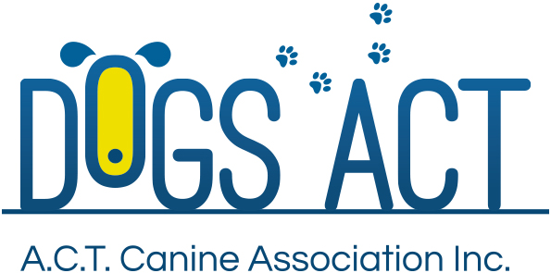
LURE COURSING – ENTHUSIASM, FOLLOW, AGILITY, SPEED, ENDURANCE
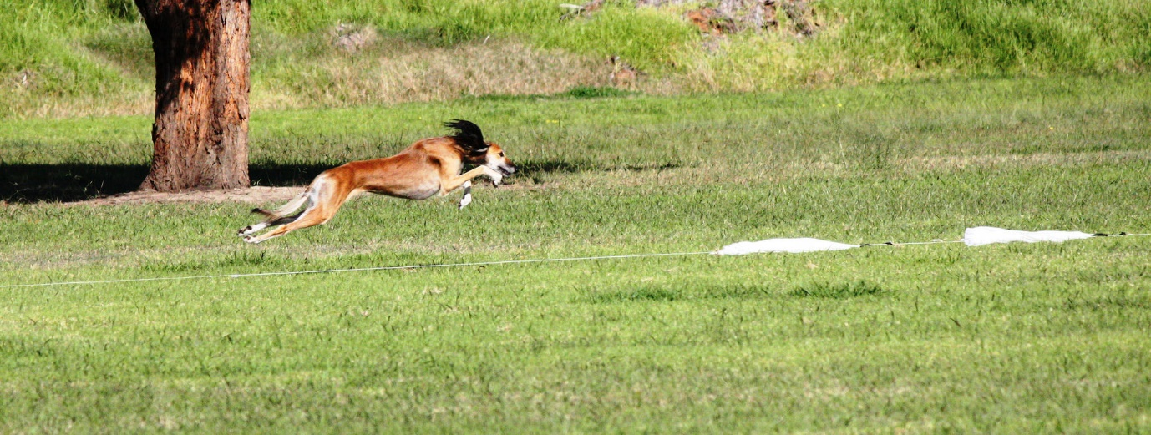

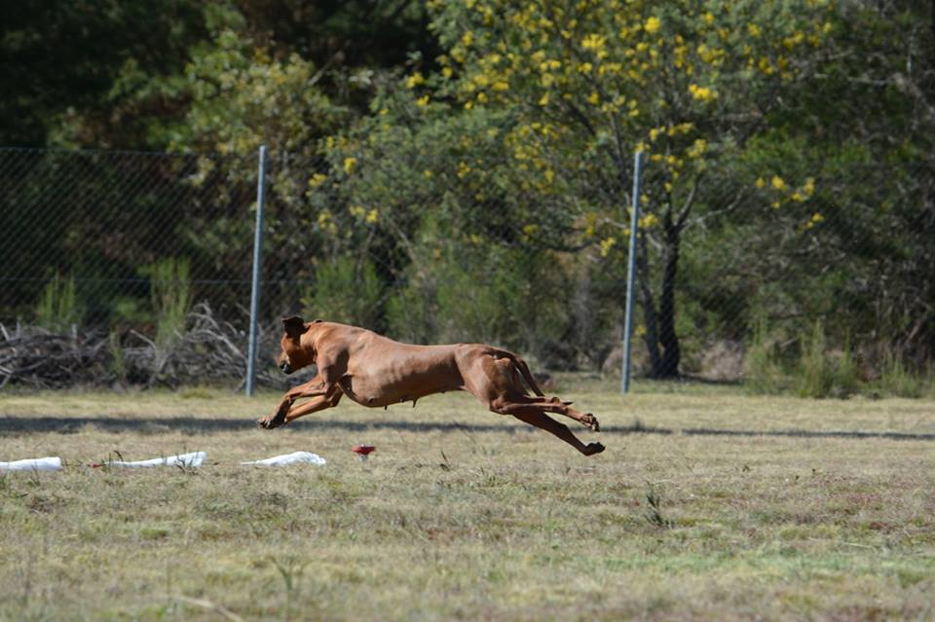
The sport of Lure Coursing was designed by sight hound owners who wanted to test their dogs in a manner that replicated hunting jackrabbits in an open field. By pulling a plastic bag around a field to simulate the path of the rabbit, they could test the dog’s functional abilities to course game.

Lure Coursing’s main focus may be for the Sighthound breeds, but it is also open to all other breeds of dogs and includes associated registered dogs. There are two streams, one for Sighthounds and the other is the Coursing Ability stream.

The sighthound stream includes the: Afghan Hound, Azawakh, Borzoi, Deerhound, Greyhound, Ibizan Hound, Italian Greyhound, Irish Wolfhound, Pharaoh Hound, Saluki, Sloughi and Whippet. Plus for Lure Coursing only - Basenji & Rhodesian Ridgeback.

The Coursing Ability stream is for all other breeds and associate registered dogs. Unregistered Sighthounds (not on the main or limited register), are also included here.

In Lure Coursing, the Lure is a plastic bag which is tied to a cord and this is pulled around the field by a motor. The course is normally between 650 – 900 m in length. Dogs are run by themselves, with the exception of the Sighthound Open stakes.

A Lure Coursing Trial is not a timed race where the fastest dog wins. Dogs are scored over the five areas of: Enthusiasm, Follow, Agility, Speed & Endurance. Dogs need to display: enthusiasm to pursue the lure; keen follow of the lure; agility over the natural obstacles on course; speed over course; and endurance to last the full distance.

Dogs participating in this dog sport must be sound, free from injury and very fit.

Further information
Further information about DOGS ACT activities including getting involved in Lure Coursing, can also be found at www.dogsact.org.au OR call our office and speak to our staff during Business Hours (Tuesday, Wednesday or Thursday – 9.30 to 2.30) on 02 6241 4404.

