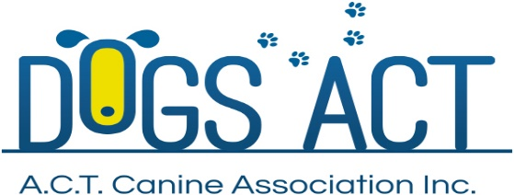
Postal entries close: 20 April 2018
On Line entries close: 27 April 2018

Obedience Titles and Rally O Trials
12 and 13 May 2018
Venue – Dogs ACT Canine Complex, Cnr Federal Highway & Stirling Ave, Mitchell, ACT
Classes | Judging Commences | Check In | Saturday 12 May | Sunday 13 May
Obedience:  UDX (A & B)  UD (A & B) | Saturday  Not before 10.00am  Sunday  Not before 9.30am | Saturday  9.15 – 9-45am  Sunday  8.45 – 9.15am | Ms Patricia Looker (VIC) | Mr Sid Schuck (NSW)
Obedience:  CDX (A & B)  CD  CCD | Saturday  Not before 10.00am  Sunday  Not before 9.30am | Saturday  9.15 – 9-45am  Sunday  8.45 – 9.15am | Ms Mandy Choice (NSW) | Ms Patricia Looker (VIC)
Rally Obedience:  All classes | Not before 9.30am | 8.15 – 8-45am | Mr Sid Schuck (NSW) | Ms Mandy Choice (NSW)
Entry Fees: $12.00 for each class entered
Catalogues: Electronic catalogue included in entry fee
Enter online at: Easy Dog Entries https://www.easydogentries.com.au
Or post to: Obedience Trial Manager, 39 Crisp Circuit, BRUCE ACT 2617
Cheques payable to Dogs ACT. No late entries will be accepted.
Enquiries: Preferred method of contact: Email elaine.temby@gmail.com. Ph or text: 0414 552 730 – no calls after 8:30pm please
Prizes: Cash Prize: 1st, 2nd, 3rd (qualifiers only) – Sash: 1st, 2nd, 3rd (qualifiers only)
Obedience Title Holders: Sash & Cash prize
Note: Paper entries - please ensure that you provide an entry form for each dog, & include the dogs jump height where applicable; for UDX, UD and CDX which class A or B and include an e-mail address on each entry form.
Dogs ACT reserves the right to make any changes that will ensure the smooth conduct of the trial, to substitute or appoint additional judges and to accept or reject entries.
Dogs ACT Regulations allow contracted judges to compete in the trials provided they do not do so in the classes they have been contracted to judge.
The Obedience Title Holders for each class will be decided using qualifying scores awarded over the two days. Each dog will be awarded 1 point for first, two points for second and so on and the dogs with the lowest number of points over the two days will be awarded Titles. To be eligible, dogs must qualify on both days.
On grounds camping is available but must be pre-booked, phone 02 6241 4404.

