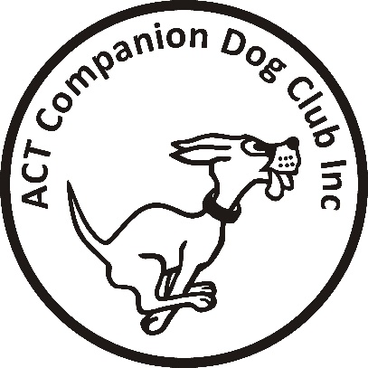
Postal Entries close: Friday 1 June 2018
Online Entries close: Sunday 10 June 2018

ACT COMPANION DOG CLUB
DOUBLE OBEDIENCE TRIAL
Saturday 16 June 2018
Venue: ACT CDC grounds, 240 Narrabundah Lane, Symonston ACT 2609
AM TRIAL PM TRIAL
Judges UDX, UD … Ms Patricia Looker (Vic) UDX … Mr Ritchie Butler (NSW)
CDX … Mr Ritchie Butler (NSW) UD, CDX … Ms Patricia Looker (Vic)
CCD, CD … Mrs Anne Butler (NSW) CCD, CD … Mrs Joanne Hagan (ACT)
Starts 9.30 am Not before 1.00pm
Check-in 8.15 - 8.45 am 12.15 – 12.45 am
Entry fee $11.00 $11.00
Entries to Show Manager (preferred)
Or by post to Obedience Trial Manager, ACT Companion Dog Club, PO Box 4048, Kingston ACT 2604,
And pay online: ACT CDC - BSB: 032-729, Account: 235628, Ref: OB0616 + surname + phone number
Catalogues posted on ACT region obedience & rallyo trialling group Facebook page
or, if requested, to email address on your entry form.
All enquiries Judith Barlow - 0403 199 847 no calls after 9pm please, judespitz@netspeed.com.au
Awards Sash for 1st, 2nd and 3rd place for qualifying scores.
Sash for all qualifying scores and titles gained on the day.
Notes: The Club reserves the right to make any changes to ensure the smooth running of the trial, including substituting or appointing additional judges, and accepting or rejecting entries.
No off-leash exercising of dogs on grounds except in designated fenced areas.
The Club shop will be open for meals, refreshments and treats for your dog.

