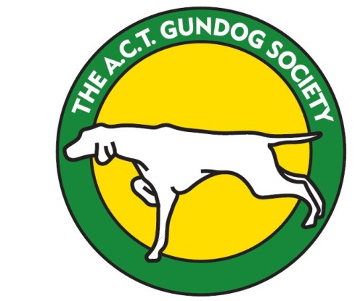
ACT GUNDOG SOCIETY
RETRIEVING TRIAL FOR GUNDOGS
To be held in the Peak View area
28th & 29th July 2018
Judges:
Saturday 28th: NOVICE Mr Byron Kendall (VIC)
RESTRICTED Mr Andrew Yeomans (VIC)
ALL AGE Mr Barry Kavanagh (VIC)
Sunday 29th: NOVICE Mr Byron Kendall (VIC)
RESTRICTED Mr Barry Kavanagh (VIC)
ALL AGE Mr Karl Britton (VIC)

Entry Fees: Novice: $18 Member/$20 non-member
Restricted & All Age: $20 Member/$22 non-member

Entries: via Easy Dog entries www.easydogentries.com
Or post to:
Retrieving Trial Secretary
18 Euroka Street
NARRABUNDAH ACT 2604

Cheques to be made out to ACT Gundog Society Inc. and included with entries
Payment may be made by direct deposit at time of entry to:
Account name: ACT Gundog Society
BSB: 062-905
Account No.: 00135312
Reference RT18+ Surname

Entries Close: Friday July 13th, 2018

Vetting: 7:30-8am Starting: 8:30am

Awards: All Stakes – Trophy & Sash 1st, 2nd and 3rd Place. Sash for 4th in Novice.

Accommodation: Bredbo Inn has accommodation and powered & non-powered caravan sites. Showers available $5. 35 minutes from trial site.
Peak View Hall grounds has camping and caravan camping available. No showers. Limited power. $10 per night. 10 minutes from trial site.
Cooma has various accommodation options. 35-40 minutes from trial site.
Note that it is ski season so accommodation should be booked early.

Catering: Bacon & Egg rolls available for breakfast at Bredbo Inn.
Communal dinner Saturday night at Bredbo Inn.
No other catering.

