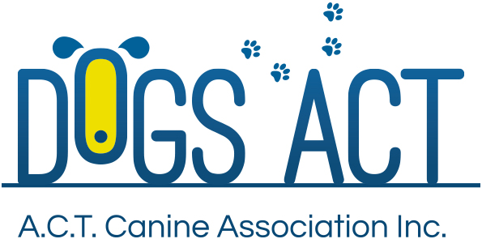
ACT Canine Association Inc. (ABN 11150955611) trading as Dogs A.C.T.

Exhibition Park, Federal Highway, Mitchell, ACT
PO Box 815 Dickson ACT 2602 Phone 02 6241 4404
Email: admin@dogsact.org.au or visit: http://www.dogsact.org.au

ACT accredited assessors are:
- Doug Sidebottom;
- Lyndall Black;
- Jim Black;
- Derek Hyde;
- Dee Hyde;
- Earnest Moore;
- Emma Parker;
- William Ranie;
- Linda Buckley; and
- Linda Stevens

