Hosted by Dogs ACT Lure Coursing Sub Committee
“Recognising Pain in your Pet”
Presented by Robyn Larson-Shelton, from Pet Miracle.
Where: Dogs ACT Room, EPIC When: 10.00am - Saturday 21 July 2018

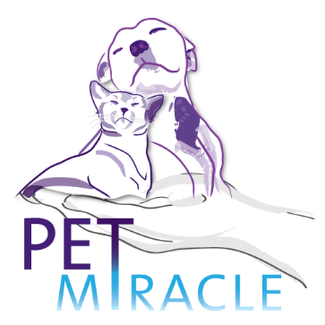
Commencing 10am:
- Presentation - ‘Recognising Pain in your Pet’ (approx. 20-30 min);
- Demonstration (on a dog) - assessing a dog standing still and in motion (approx. 30-45 min);
- Question time.
Light refreshments, Tea & Coffee provided.
About our presenter:
Robyn has been a musculoskeletal remedial therapist for pets for 10 years. She has completed Smart Bowen Small Animals Essentials and has other qualifications in horses that also apply to dogs, including Biomechanical Assessment, Photonic Therapy, Myofascial Release and Fascial Taping. Robyn routinely attends Horse Endurance rides treating the Equine competitors. She has attended Lure Coursing trials and other dog activities, so has a full appreciation of the physical requirements of your canine companion / athlete in those activities. .
You can find her on Face Book under Pet Miracle @petsfeelbetter
Robyn will be available for a limited number of private sessions with your dog after the completion of the presentation. Sessions are 30 mins & cost $50. Must be pre-booked direct with Robyn on 0431 387 787

Registration closes: postal 14 July or email 18 July 2018.
Complete below details and email to helen@mosslar.net or mail to “Event Manager, 49 Tewksbury Circuit, Theodore ACT 2905”
Name: ______________________________________ Dogs ACT / NSW membership: ________________
Email: _______________________________________________ Phone:___________________________
Cost: $15.00 per person. Cash / Cheque (payable to Dogs ACT) / Credit Card (Visa / Mastercard)
Name on Credit Card: __________________________________________________
Number: __ __ __ __ / __ __ __ __ / __ __ __ __ / __ __ __ __ Expire: __ __ / __ __

