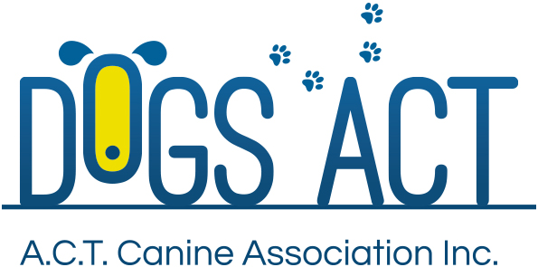
Summer Festival Shows
Saturday 19th and Sunday 20th January 2019
Three All Breeds Championship Shows over Two days
THESE SHOWS TO HELD UNDER THE MARKET SHEDS
Exhibition Park in Canberra, Federal Highway, Canberra
Classes: 1, 2, 3, 4, 5, 10, 11 & 18 (dogs & bitches)

 | SATURDAY PM  5pm Start | SUNDAY 8.00 AM | SUNDAY PM  Not before 12.00 noon
Toys | Ms S McMahon (NSW) | Mrs B Balaam (Qld) | Mrs J Watt (Qld)
Terriers | Mr E Ryder (Qld) | Mrs S McMahon (NSW) | Mrs S Pattison (Qld)
Gundogs | Mrs S Pattison (NSW) | Ms D Breman (NSW) | Mr E Ryder (Qld)
Hounds | Ms D Breman (NSW) | Mr E Ryder (Qld) | Mrs B Balaam (Qld)
Working Dogs | Mr R McMahon (NSW) | Mrs S Pattison (NSW) | Mr E Hardwicke (NSW)
Utility | Mrs J Watt (Qld) | Mr E Hardwicke (NSW) | Mrs S McMahon (NSW)
Non Sporting | Mrs B Balaam (Qld) | Mrs J Watt (Qld) | Ms D Norquay (NSW)
GENERAL SPECIALS | Mrs B Balaam (Qld) | Mr E Ryder (Qld) | Mrs S Pattison (NSW)

Judging commences: Saturday 5PM - No setting up before 4pm
Sunday - 8.00 am – AM Show and not before 12.00 Noon for the PM Show
Trophies Trophy and sash
Entry Fees: $13.00 per class, numbers to be collected at the show.
Remittances: Dogs ACT
Catalogue: $5.00 pre ordered or online only, there will be a combined catalogue for all 3 shows, no catalogues available for sale on the day
Entries close: 4th January 2018 (postal)
9.00am 14th January 2018 (online)
NO REFUNDS AFTER 4th JANUARY 2018
Email enquiries: admin@dogsact.org.au
NUMBER CARDS TO BE COLLECTED ON THE DAY OF THE SHOW
Dogs ACT hot weather policy applies – PH (02) 6241 4404
Entries to: Show Secretary, PO BOX 815, DICKSON ACT 2602
Ph: (02)6241 4404 (9.30am to 2.30pm)
email: admin @dogsact.org.au
Dogs ACT reserves the right to change or reallocate judges as necessary.
Show Committee members do not handle at these shows.
On grounds camping must be pre-booked, phone 02 6241 4404

