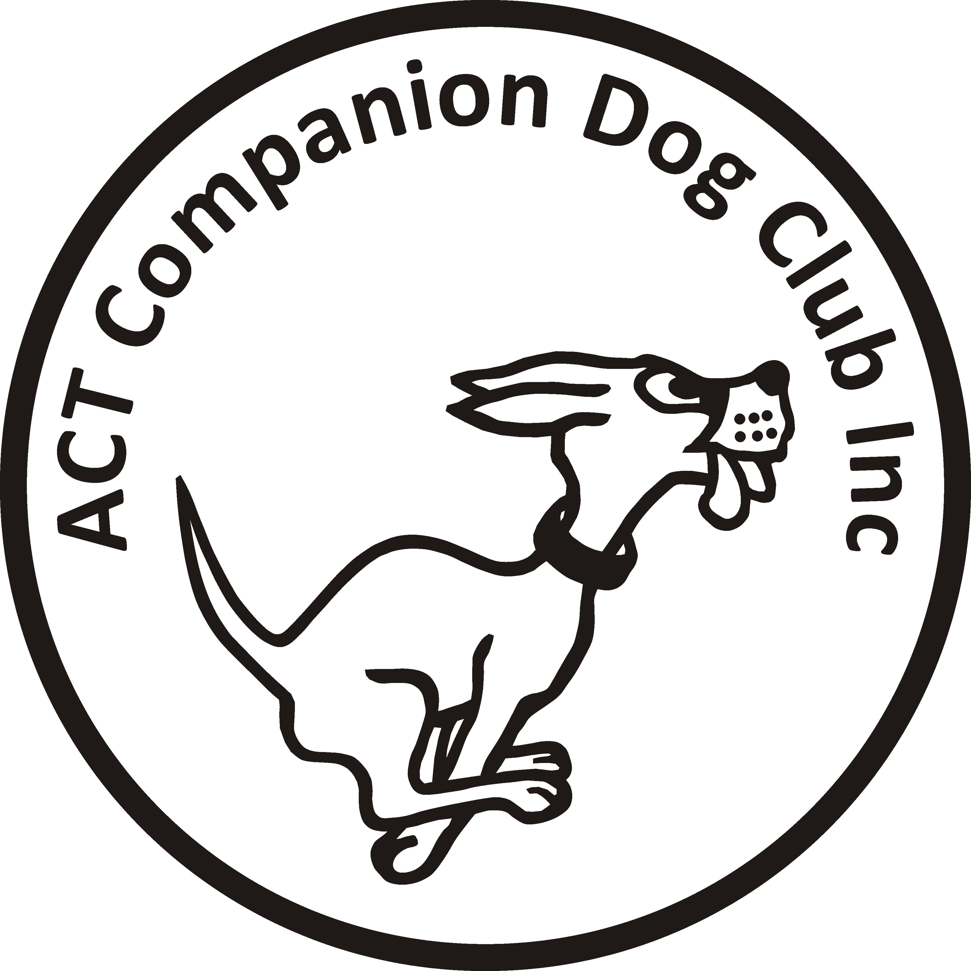
Postal Entries close: Friday 1 March 2019
Online Entries close: Friday 8 March 2019

ACT COMPANION DOG CLUB
EVENING OBEDIENCE TRIAL
6.00pm Friday 15 March 2019
Venue: CDC grounds, 240 Narrabundah Lane, Symonston ACT 2609
Judges UDX, CDX … Mr Charlie Giles (ACT)
UD … … … … … Ms Julie Cutts (ACT)
CD, CCD … … … Dr John Montgomery (ACT)
Starts 6.00pm
Check-in 5.15-5.45pm
Entry fee $11.00

Entries to Show Manager
Or by post to Obedience Trial Manager, ACT Companion Dog Club, PO Box 4048, Kingston ACT 2604. Pay online: ACT CDC - BSB: 032-729, Account: 235628, Ref: OB1118 + surname + phone number
Catalogues posted on ACT region obedience & rallyo trialling group Facebook page
or, if requested, to email address on your entry form.
All enquiries Carmen Kong - 0416 139 263 no calls after 9pm please, or carmen.kong@yahoo.com
Awards Sash for 1st, 2nd and 3rd place for qualifying scores.
Sash for all qualifying scores and titles gained on the day.
Notes: The Club reserves the right to make any changes to ensure the smooth running of the trial, including substituting or appointing additional judges, and accepting or rejecting entries.
No off-leash exercising of dogs on grounds except in designated fenced areas.

