+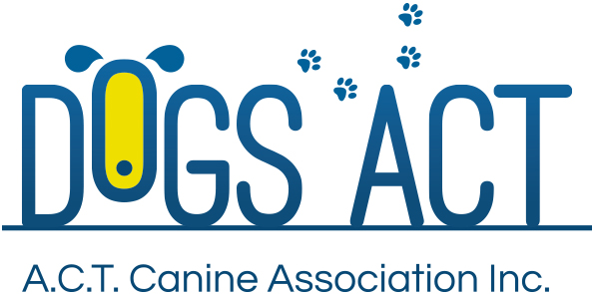
Summer Festival Shows
Sunday 27th and Monday 28th January 2019
THESE SHOW TO HELD UNDERCOVER IN THE MARKET SHEDS
Four All Breeds Championship Shows over two days
Exhibition Park in Canberra, Federal Highway, Canberra
Classes: 1, 2, 3, 4, 5, 10, 11 & 18 (dogs & bitches)

 | SUNDAY 8.00 AM | SUNDAY PM  Not before 12.00 noon | MONDAY 8.00 AM | MONDAY PM  Not before 12.00 noon
Toys | Mr B Riddell (NSW) | Ms S Lancaster (NSW) | Ms. K Rolfe (NSW) | Ms C Speed (Qld)
Terriers | Ms S Lancaster (NSW) | Mr K Iggleden (Qld) | Ms Y Meintjes (NSW) | Ms L Hindley (ACT)
Gundogs | Ms Y Meintjes (NSW) | Ms N Abela (NSW) | Mr K Iggleden (Qld) | Rev C Seymour (NSW)
Hounds | Rev C Seymour (NSW) | Ms C Speed (Qld) | Ms S Lancaster (NSW) | Ms N Abela (NSW)
Working Dogs | Ms C Speed (Qld) | Rev C Seymour (NSW) | Ms N Abela (NSW) | Ms Y Meintjes (NSW)
Utility | Mr K Iggleden (Qld) | Mr B Riddell (NSW) | Rev C Seymour (NSW) | Ms S Lancaster (NSW)
Non Sporting | Ms N Abela (NSW) | Ms Y Meintjes (NSW) | Ms C Speed (Qld) | Mr K Iggleden (Qld)
GENERAL SPECIALS | Ms N Abela (NSW) | Mr K Iggleden (Qld) | Rev C Seymour (NSW) | Ms C Speed (Qld)

Judging commences: 8.00 am – AM Show and not before 12.00 Noon for the PM Show
Trophies Trophy and sash
Entry Fees: $13.00 per class, numbers to be collected at the show.
Remittances: Dogs ACT
Catalogue: $5.00 pre ordered or online only, there will be a combined catalogue for each day, no catalogues available for sale on the day
Entries close: 10th January 2019 (postal)
9.00am 21st January 2019 (online)
NO REFUNDS AFTER 10th JANUARY 2019
Email enquiries: admin@dogsact.org.au
NUMBER CARDS TO BE COLLECTED ON THE DAY OF THE SHOW
Dogs ACT hot weather policy applies – PH (02) 6241 4404
Entries to: | Show Secretary, PO BOX 815  DICKSON ACT 2602  Ph: (02)6241 4404 (9.30am to 2.30pm)  email: admin @dogsact.org.au
Dogs ACT reserves the right to change or reallocate judges as necessary.
Show Committee members do not handle at these shows.
On grounds camping must be pre-booked, phone 02 6241 4404

