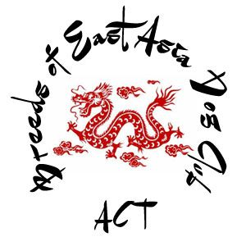
6th Championship Show
Exhibition Park, Mitchell ACT
(Entry through Wells Station road only)
Saturday 9th March 2019
Classes to be judged: 1, 2, 3, 4, 5, 10, 11 & 18 – Dogs and Bitches
Breeds - Akita, Akita Japanese ,Chow Chow, Chinese Crested, , Japanese Chin, Japanese Spitz, Lhasa Apso, Pekingese, Pug, Shar Pei, Shiba Inu, Shih Tzu, Siberian Husky, Tibetan Mastiff, Tibetan Spaniel, Tibetan Terrier.
Judge: MR. C.T. Moore (VIC)
Judging to commence after Mr Moore’s morning group for CABKC
(With Akita’s and judged in alphabetical order)
Entry fees:
Non-members - first entry $20 and subsequent entries $17 with baby $12
Members - first entry $15 and subsequent entries $12 with baby $10
Memberships/renewals can be paid with entries. ($25 per year)
Please note - Financial year is 1st March – 28th Feb
Catalogues: Free with entries
Entries close: 25th February 2019 with
Show secretary
7 Beaver Close, Wanniassa ACT 2903
Email - breedsofeastasiadogclubact@gmail.com
Phone:02 62318494 M: 0409713904 (no calls after 9pm please)
Numbers cards collected on the day.

