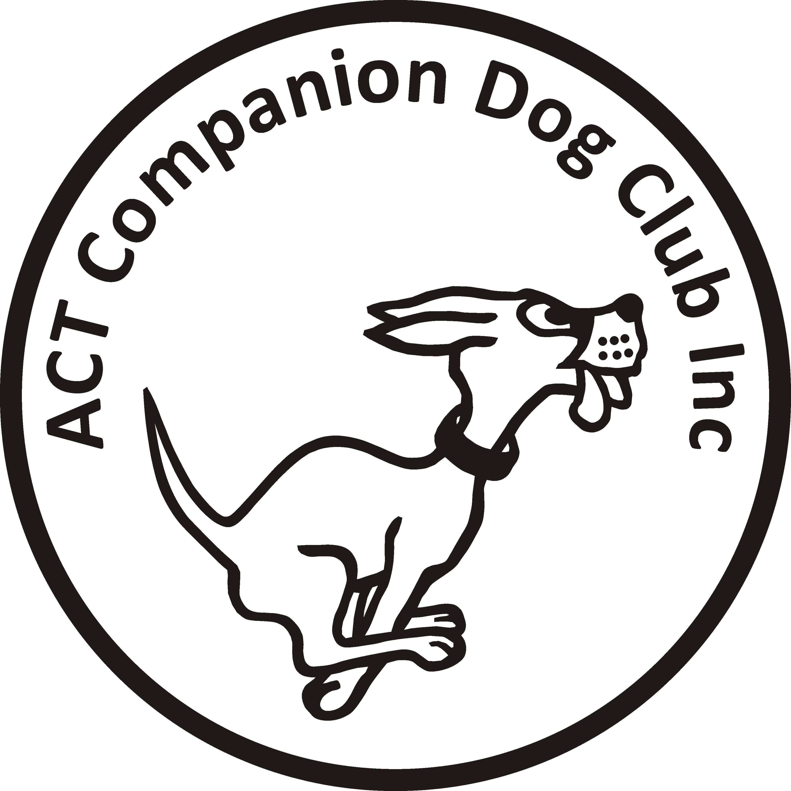

ACT COMPANION DOG CLUB Inc.
Tracking Trial
20 & 21 July 2019
Venue: Canberra area

Judge: Denise Chrystal (VIC)
Check In and Vetting: 7:30 am
Trial Commences: 8am

Entry fee: $25

Entries close: 1 July 2019
The Tracking Trial Manager
PO Box 4048 KINGSTON ACT 2604

Email: contact@actcdc.org.au

Please include an email address with entry for map and further
details of trial.

If more entries are received than can be accommodated in the trial a ballot will be held and competitors notified of the outcome.

The ACT Companion Dog Club reserves the right to make any changes that will ensure the smooth running of the trial, including substituting or appointing additional judges, and to accept or reject entries.

In the event that there are suitable tracks available and sufficient time and helpers, competitors may be offered the opportunity to ‘track on’ – otherwise one track per dog

