THE HOUND CLUB OF THE ACT
TWO CHAMPIONSHIP SHOWS
EPIC SHOWGROUND, Cnr Federal Hwy & Stirling Ave Mitchell ACT
SATURDAY 14 SEPTEMBER 2019
Show 1 - JUDGE MR NICO MEYER (QLD)
Show 2 - JUDGE MRS WENDY BOCE (VIC)
Judging commences: 10am for Show 1 & 11am for Show 2
Order of judging: All Hound Breeds Alphabetically
Classes to be judged: 1, 2, 3, 4, 5, 10, 11, 14 & 18 (dogs and bitches) at Both Shows
Veterans Sweepstakes 7-10 & Over 10 years to judged at the conclusion of both shows,
Judged by both Judges. 1st, 2nd & 3rd place
Entry Fees: Members $12 first entry (includes Catalogue), $10 subsequent entries
Non-Members $15 first entry (includes Catalogue), $12 subsequent entries
Baby Puppies $8
Membership: $10 per household, payable with entry.
Catalogues: One Catalogue for both Shows, Included in first entry, or $5 on the day.
Advertising in Catalogue: $30 Full page, copy to be emailed to Secretary no later than 1/9/19.

Best of Breed Sponsorship: Cash Envelope - $15 per Class per show (payable online, Specify Breed)

Raffle: Orivet Vouchers & Jewellery & much more, Tickets $2 ea or 3 for $5, payable online

Mail Entries to: Secretary PO Box 815 Dickson ACT 2602. Ph: 0408844529

Cheques made payable to: The Hound Club of the ACT Inc

Entries close: Mail – Thurs 5 September 2019. Online – Tues 10 September 2019

Camping: Contact Dogs ACT via email at admin@dogsact.org.au
Powered and unpowered sites available. $30 per night pre paid, $35 per night casual.
All Exhibitors, Family & Friends are invited to a meet and greet with the
Judges & Committee following the completion of judging of both shows.
Drinks will be provided, please bring a plate to share.
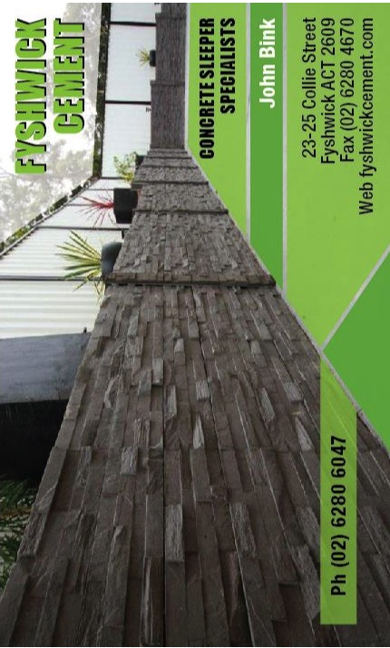
ORGANISERS RESERVE THE RIGHT TO ALTER JUDGES AS NECESSARY TO ENSURE THE SMOOTH RUNNING OF THE SHOWS.
MAJOR SPONSORS

