ACT Ladies Kennel Club & Canberra All Breeds Kennel Club

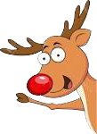
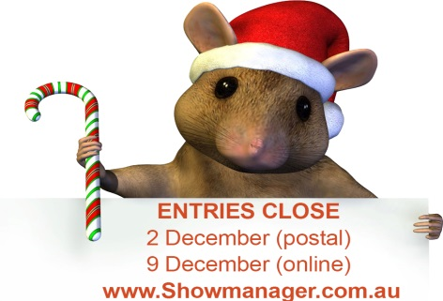
2019 CHRISTMAS EXTRAVAGANZA

6 ALL-BREEDS CHAMPIONSHIP SHOWS – AM & PM

13, 14 & 15 DECEMBER 2019
(Friday | Saturday | Sunday)

Exhibition Park, Federal Highway, Canberra
Classes to be judged: 1, 2, 3, 4, 5, 10, 11 & 18 (dogs & bitches)

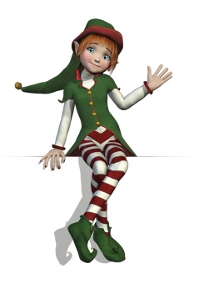
 | ACT LKC  Fri AM |  | CABKC  Fri PM | ACT LKC  Sat AM | CABKC  Sat PM | ACT LKC  Sun AM |  | CABKC  Sun PM
Toys | Ms V Hutton  (NSW) |  | Ms S Rose  (NSW) | Mr S Schwerdt  (SA) | Mr P Martin  (SA) | Ms L Niemann  (SA) |  | Ms S Hewinson  (QLD)
Terriers | Mr S Schwerdt  (SA) |  | Ms V Hutton  (NSW) | Ms S Bownds  (NSW) | Ms S Hewinson  (QLD) | Mr P Martin  (SA) |  | Ms L Niemann  (SA)
Gundogs | Ms L Niemann  (SA) |  | Mr S Schwerdt  (SA) | Ms S Rose  (NSW) | Ms S Bownds  (NSW) | Ms S Hewinson  (QLD) |  | Mr P Martin  (SA)
Hounds | Mr P Martin  (SA) |  | Ms L Niemann  (SA) | Ms V Hutton  (NSW) | Ms S Rose  (NSW) | Ms S Bownds  (NSW) |  | Mr S Schwerdt  (SA)
Working | Ms S Hewinson  (QLD) |  | Mr P Martin  (SA) | Ms L Niemann  (SA) | Ms V Hutton  (NSW) | Ms S Rose  (NSW) |  | Ms S Bownds  (NSW)
Utility | Ms M Butcher  (NSW) |  | Ms S Hewinson  (QLD) | Mr P Martin  (SA) | Mr S Schwerdt  (SA) | Ms V Hutton  (NSW) |  | Ms S Rose  (NSW)
Non-Sporting | Ms S Rose  (NSW) |  | Ms M Butcher  (NSW) | Ms S Hewinson  (QLD) | Ms L Niemann  (SA) | Mr S Schwerdt  (SA) |  | Ms V Hutton  (NSW)
General Specials | Ms S Hewinson  (QLD) |  | Mr P Martin  (SA) | Mr S Schwerdt  (SA) | Ms S Rose  (NSW) | Ms L Niemann  (SA) |  | Ms V Hutton  (NSW)
Order of judging: 8.30 am each day with groups in alphabetical order
PM Shows not before 12 noon each day with groups in alphabetical order
Entry Fees: $13.00 per entry for ALL classes.
Entries Close: 2 December 2019 (postal) | 9 December 2019 (online)
Enter online with SHOW MANAGER (www.showmanager.com.au) or send to
GPO Box 2428, Canberra ACT 2601
Provide email address for confirmation of receipt of paper entries
One entry form per dog and this can be used for all shows to be entered
No refunds for entries after 2 December 2019
Three-show Catalogue: Printed - $5 (pre-purchase only) per club
Online – FREE if email is provided
 |  | Numbers will not be mailed and can be picked up on the day
Prizes: Trophy and sash for BIG, RUBIG, BIS, RUBIS
Classes in Group and in Classes in Show for all shows.
All remittances for ALL shows should be made payable to
ACT Ladies Kennel Club

Get your Christmas gear on for the last ACT shows in 2019!
Junior Handlers & Tiny Tots at lunchtime Saturday with a visit from Santa!
Exhibitors Please Note $$$$$$ Prizes for best decorated festive canopies on Saturday!!! (1st $150; 2nd $100; 3rd $50) Join in the fun with friends!
RSVPs for children attending the show are ESSENTIAL to ensure that the elves have enough goodie bags for Santa to hand out!
Please advise name and age of child to email actladieskc@gmail.com
Show Committees do not enter or handle exhibits at these events
The Clubs reserve the right to substitute or appoint additional judges if required
Dogs ACT hot weather policy applies

