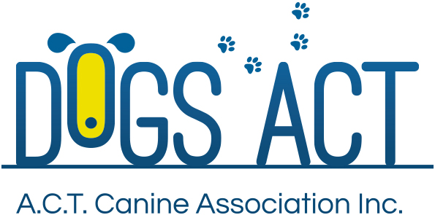  ACT Canine Association Inc. (ABN 11150955611) trading as Dogs A.C.T.  Exhibition Park, Federal Highway, Mitchell, ACT.  PO Box 815, Dickson ACT 2602. Phone 02 62414404.  Email: administrator@dogsact.org.au or visit: http://www.dogsact.org.au  Office hours 9.30am to 2.30pm Tuesday to Thursday | Request for a search of Dogs A.C.T. documents
Important - This is not a freedom of information search request.
 |  | $41.00 | Registrations and transfers | Your animals only.
 |  | $52.00 | Database search | Your membership or animals only.
 |  | $75 | Documents search | Non database - Relevant to this financial year.
 |  | Minimum amount - $75.00 – Per hour rate - See information below.
 |  | $197 | Archived documents | Non database - Outside this financial year
 |  | Minimum amount - $193.00 – plus Per hour rate - See information below.
 |  | Fees current as at 1 August 2019
The prices listed above DO NOT include printing & postage, where the amount of printing & postage exceeds normal letter size.

Name |  | Membership Number
Name |  | Membership Number
Contact address
(address line 2)
Email address |  | Phone number
Email address |  | Phone number

I/We hereby request the following search

I/We understand that –
- Search fee is non-refundable.
- All searches are subject to the state/territory privacy laws.
- Where any search would deplete the daily staffing levels for an unreasonable time, the search will not take place or the search fee will reflect the cost of resources used during the search.
- Due to staffing levels other work has priority over search processes.
- Where an animals or search is subject to more than one owner/membership, both persons must sign this document.
- It is accepted that archived document search may not produce required data but applicable fee must be paid for search (length documents held in archives is as per statutory requirements).
Signature |  | Signature
Date |  | Date

 | OFFICE USE ONLY
Date received |  |  | Date of search |  | Date search completed
 |  |  | Yes / No |  | Yes / No
Date applicant advised of result |  |  | Search successful? |  | Applicant satisfied?

NOTES RELEVANT TO SEARCH (Attach copy of documents where required).
Document/s located? |  | YES / NO
Documents able to be reproduced? |  | YES / NO
Duration of search. |  | Hours |  |  | Minutes
Final cost of search: | Cost to Dogs ACT: | $ |  | Cost to applicant: |  | $

