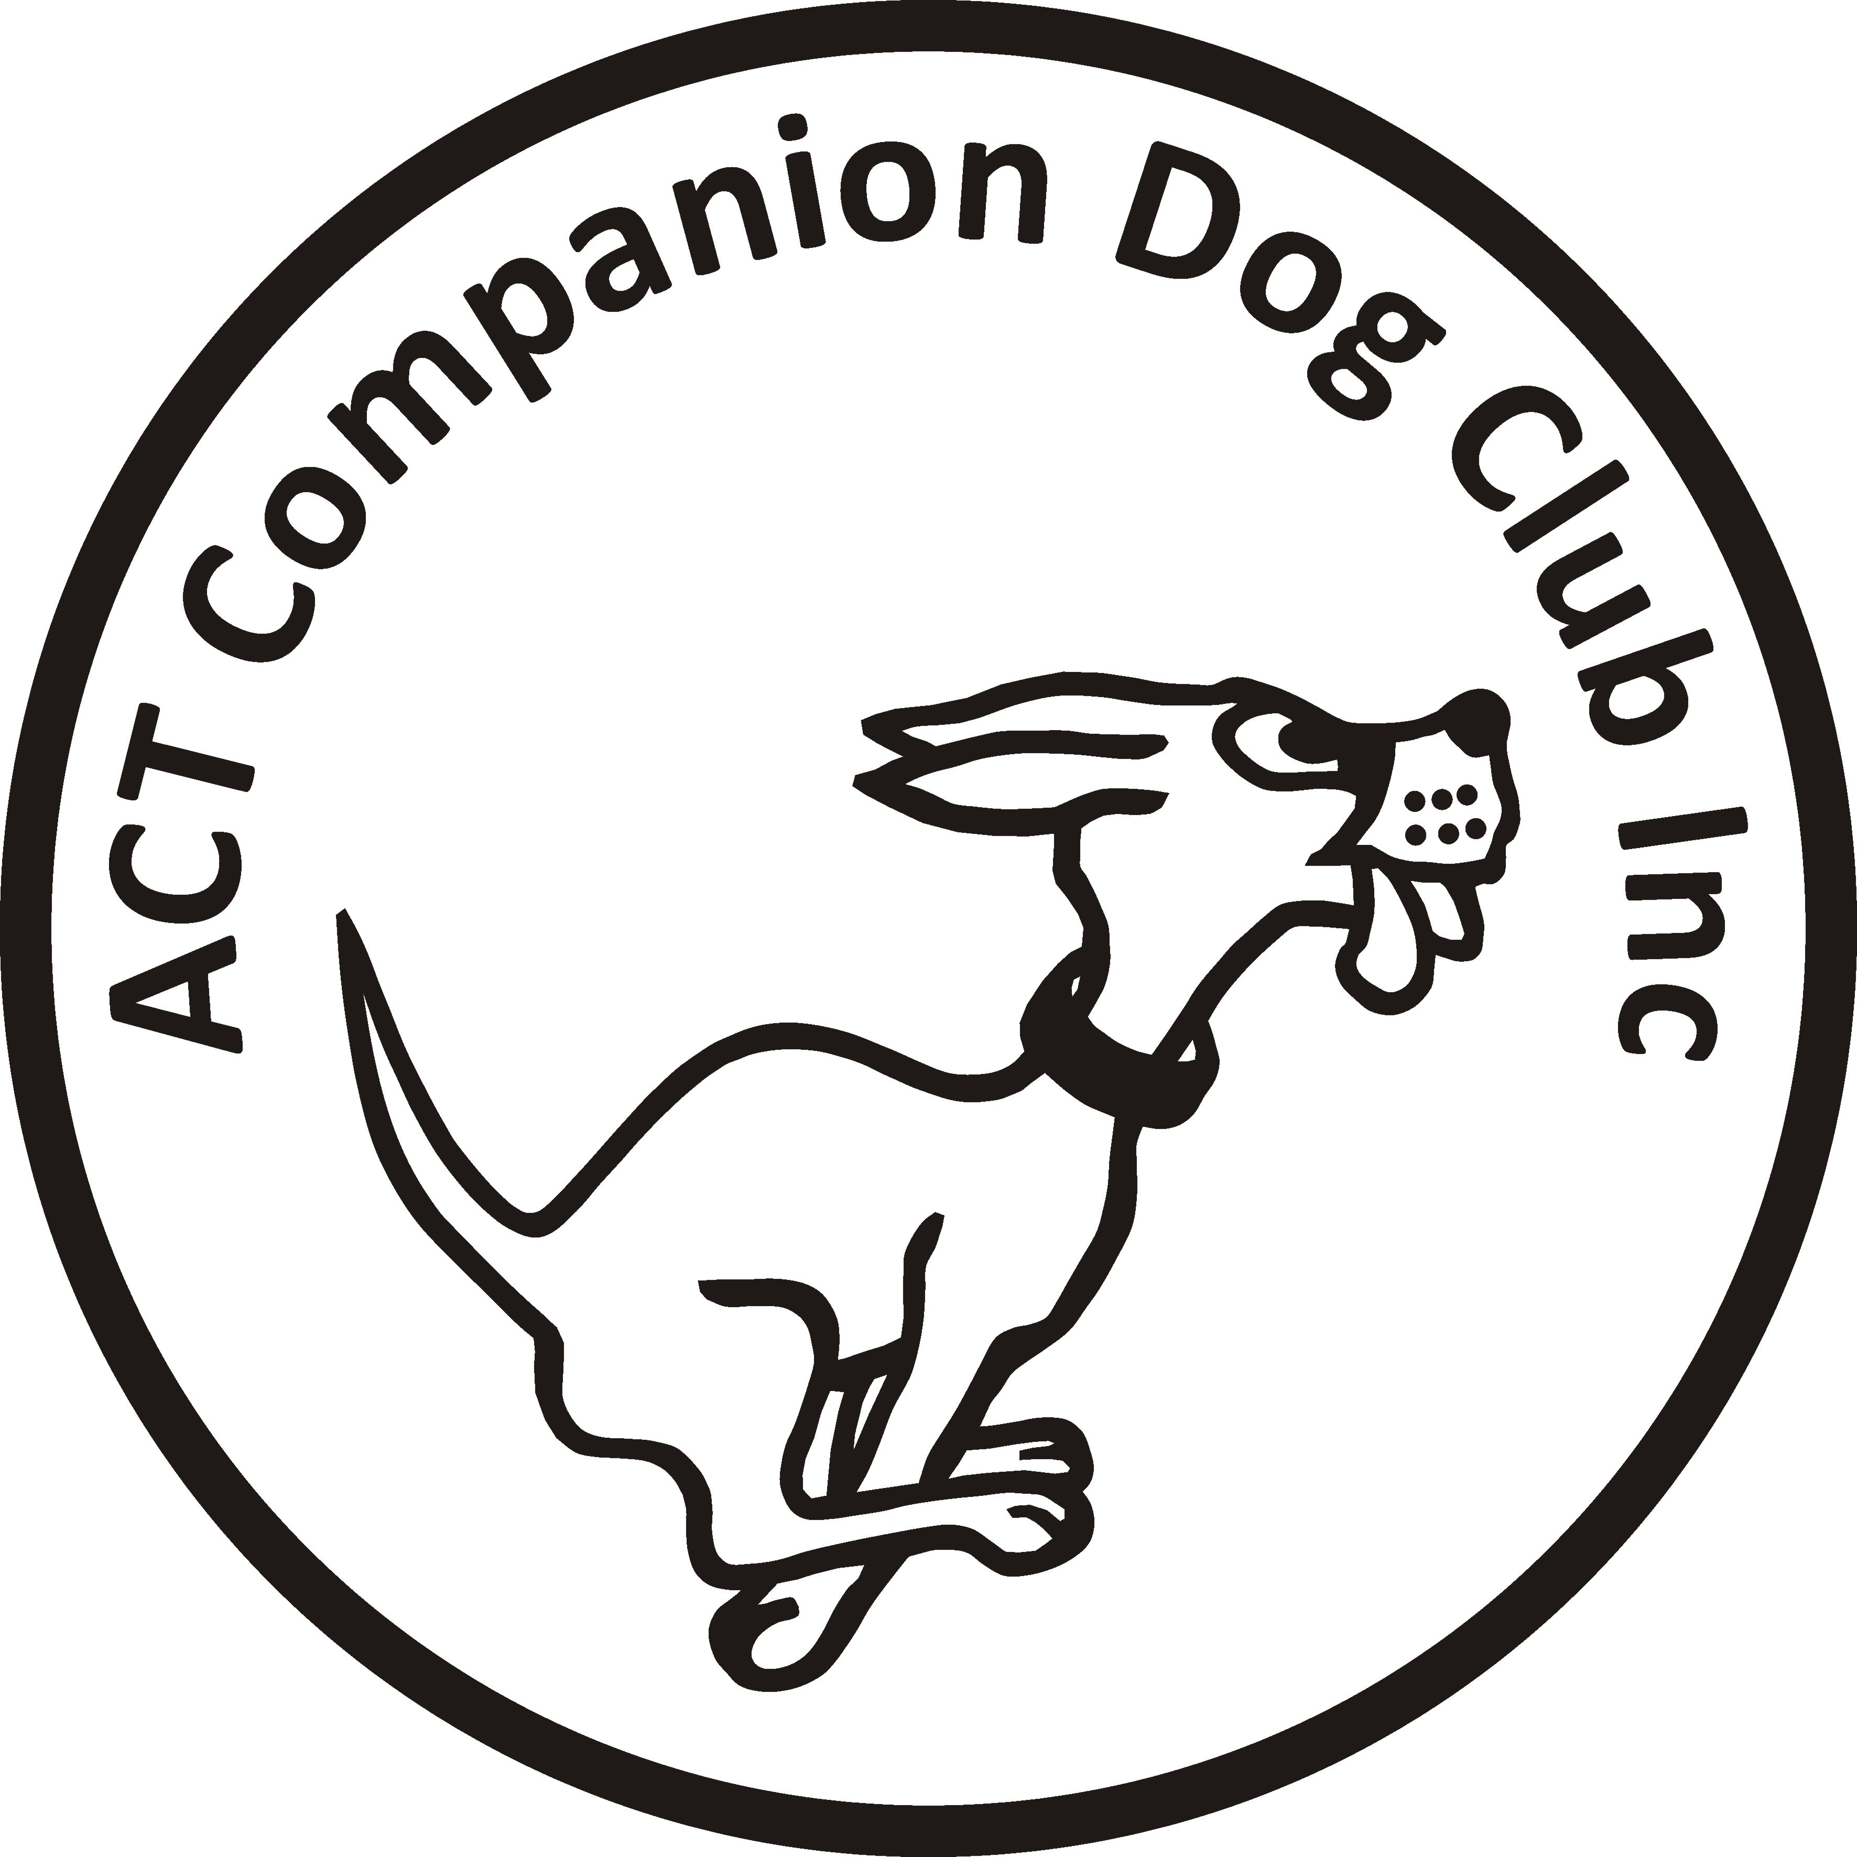
Postal Entries close: Friday 29 May 2020
Online Entries close: Friday 5 June 2020

ACT COMPANION DOG CLUB
DOUBLE OBEDIENCE TRIAL
Saturday 13 June 2020
Venue: CDC grounds, 240 Narrabundah Lane, Symonston ACT 2609
Judges | Trial 1 | Trial 2
UDX | Mrs Judy Van Der Vegt (NSW) | Mr Charlie Giles (ACT)
UD | Mr Charlie Giles (ACT) | Mr Charlie Giles (ACT)
CDX | Mrs Jo Washington-King (ACT) | Mrs Judy Van Der Vegt (NSW)
CD, CCD | Mrs Anne Butler (NSW) | Mrs Jo Washington-King (ACT)
Judging | 9.00am | After Trial 1 and not before 12.30pm
Check-in | 8.15-8.45am | 8.15-8.45am and 11.45am-12.15pm

Entry fee $11.00
Entries to Show Manager
Or by post to Obedience Trial Manager, ACT Companion Dog Club, PO Box 4048, Kingston ACT 2604. Pay online: ACT CDC - BSB: 032-729, Account: 235628, Ref: OB1306 + surname + phone number
NO EMAIL ENTRIES
Catalogues posted on ACT region obedience & rallyo trialling group Facebook page
or, if requested, to email address on your entry form.
All enquiries Carmen Kong - 0416 139 263 no calls after 9pm please, or carmen.kong@yahoo.com
Awards Sash for 1st, 2nd and 3rd place for qualifying scores.
Sash for all qualifying scores and titles gained on the day.
Notes: The Club reserves the right to make any changes to ensure the smooth running of the trial, including substituting or appointing additional judges, and accepting or rejecting entries.
No off-leash exercising of dogs on grounds except in designated fenced areas. Dogs ACT Regulation 8.15 states that contracted Judges may compete provided they do not do so in classes they have been contracted to judge.

