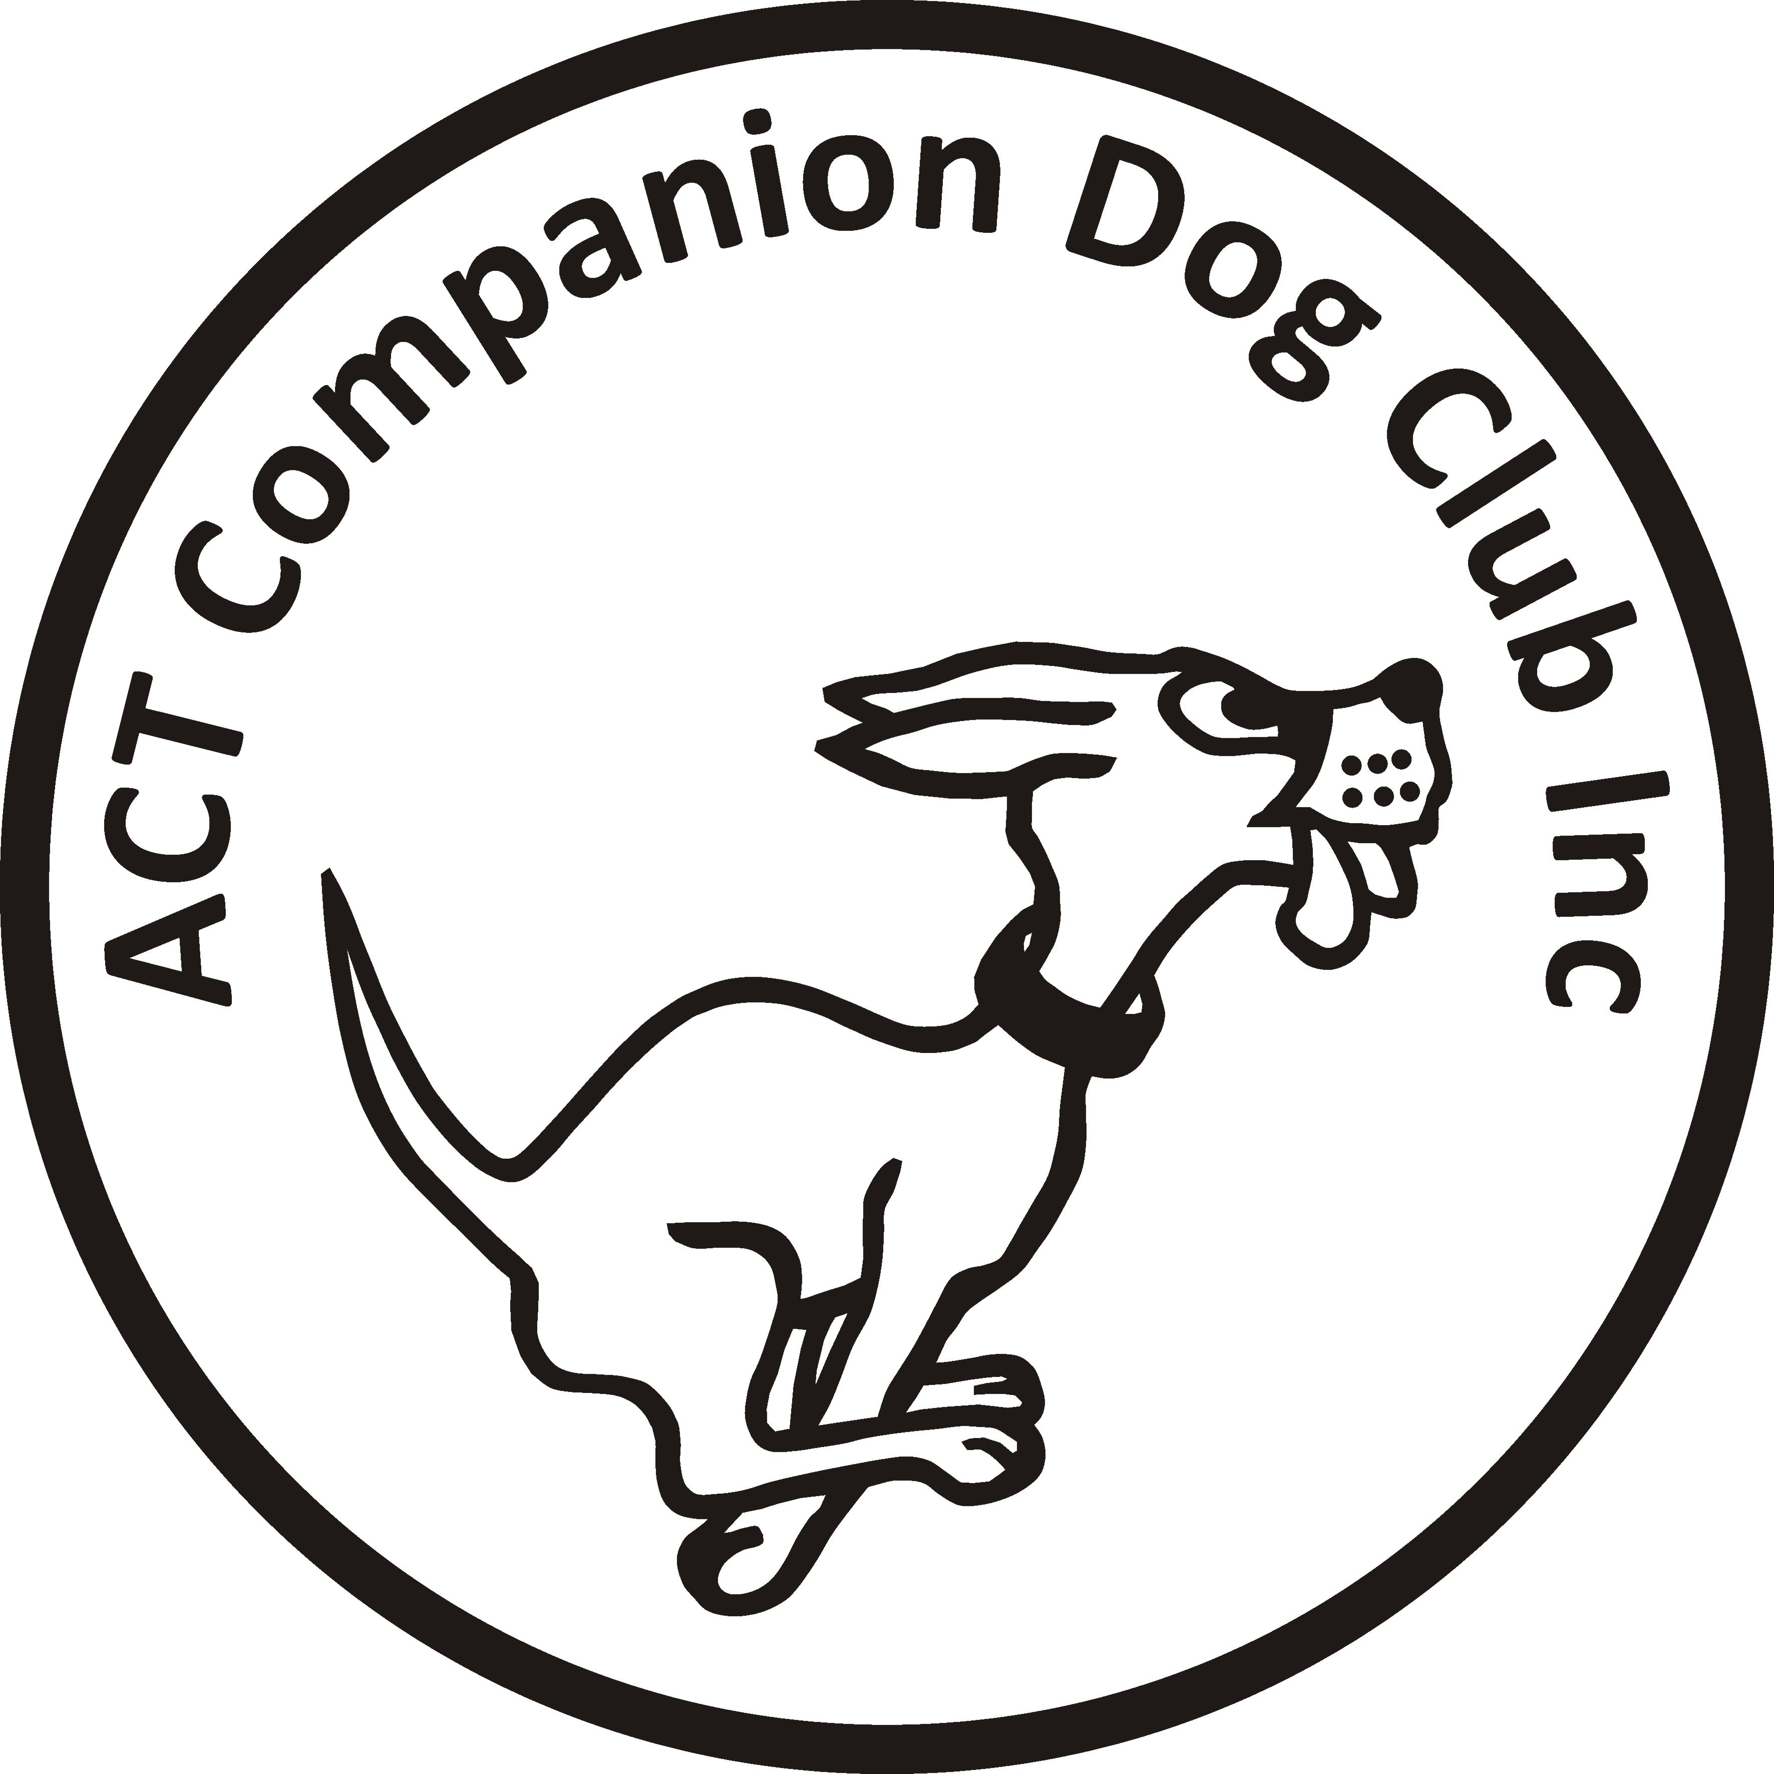
Entries (online only) close: Saturday 30 October 2020
Entries will be restricted to residents: of the ACT; in the postcodes 2620, 2621, 2622, 2581 and 2582; currently attending obedience training at ACT dog clubs or the Queanbeyan Dog Club.

ACT COMPANION DOG CLUB
EVENING OBEDIENCE TRIAL
6.00pm, Saturday 7 November 2020
Venue CDC grounds, 240 Narrabundah Lane, Symonston ACT 2609

Judges UDX, UD Mr Charlie Giles (ACT)
CDX Ms Jo Washington-King (ACT)
CD, CCD Mr Jake Blight (NSW)
Starts 6.00pm Check-in: 5.15-5.45pm
Entry fee $11.00
Entries to Show Manager (no postal entries)
Catalogue posted on ACT region obedience & rallyo trialling group Facebook page
or, if requested, to your email address.
All enquiries Judith Barlow - 0403 199 847 no calls after 9pm please, judespitz@netspeed.com.au
Awards Sash for 1st, 2nd and 3rd place for qualifying scores.
Sash for all qualifying scores and titles gained on the day.
Conditions of entry
By entering this event you agree to follow ACT Government, Dogs ACT and ACT Companion Dog Club COVID-19 guidelines
- ACT Government COVID-19 restrictions: https://www.covid19.act.gov.au/what-you-can-do
- Should it be necessary to restrict the number of entries due to COVID-19 requirements or cancel the trial due to an outbreak of COVID-19, entrants will be advised, and refunds provided
- If you have any symptoms of COVID-19 or have been in contact with anyone suspected of having COVID-19, please stay at home
- The Club shop will not be open. BYO meals and refreshments.
- The ring gates will be locked open
- Failure to adhere to any instruction issued by an official shall result in the handler being required to immediately leave the grounds
- The clubhouse will be closed and the only people permitted entry will be trial officials
- The outside toilet which is part of the workshop is available for use by competitors.
- No off-leash exercising of dogs on grounds except in designated fenced areas
- Only competitors and their dogs are permitted on the grounds, no family or friends.
- The club reserves the right to make any changes to ensure the smooth running of the trial, including substituting or appointing additional judges, and accepting or rejecting entries.

