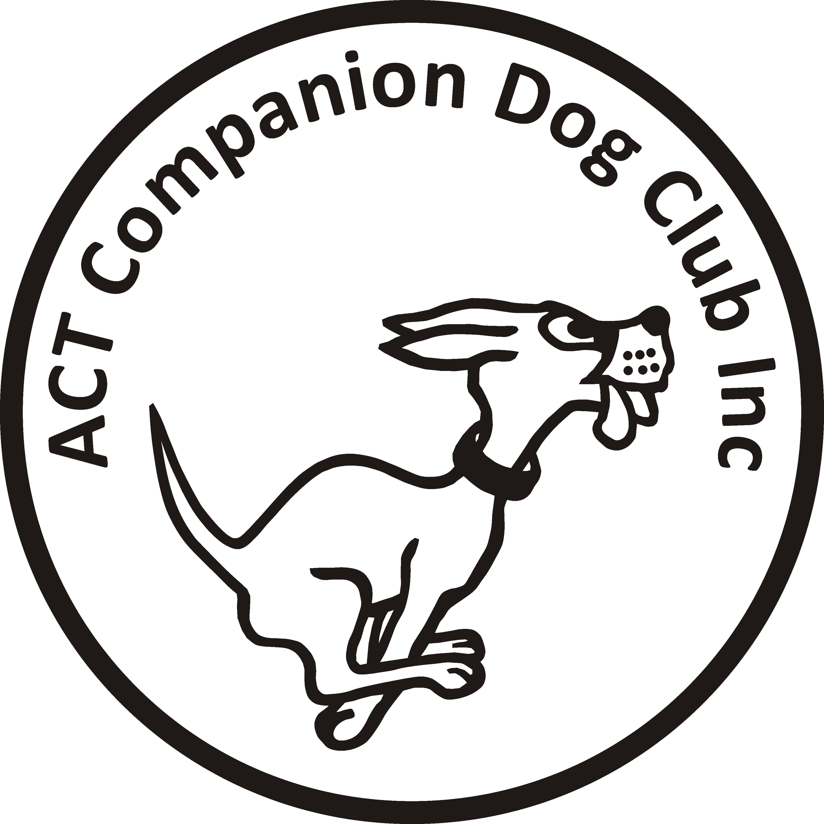
Entries (online only) close: Sunday 7 March 2021

ACT COMPANION DOG CLUB
Evening OBEDIENCE TRIAL
6.00pm, Saturday 13 March 2021
Venue ACT CDC grounds, 240 Narrabundah Lane, Symonston ACT 2609

Judges UDX, CD Mr John Green (ACT)
UD, CDX Mr Charlie Giles (ACT)
CCD Ms Nadia Badger (NSW)
Starts 6.00pm Check-in: 5.15-5.45pm
Entry fee $11.00
Entries to Show Manager (no paper entries)
Dogs ACT Rep: Ms Cath Perry
Catalogue posted on ACT region obedience & rallyo trialling group Facebook page
or, if requested, to your email address.
All enquiries Judith Barlow - 0403 199 847 no calls after 9pm, judespitz@netspeed.com.au
Awards Sash for 1st, 2nd and 3rd place for qualifying scores.
Sash for all qualifying scores and titles gained on the day.
Conditions of entry
By entering this event you agree to follow ACT Government, Dogs ACT and ACT Companion Dog Club COVID-19 guidelines
- ACT Government COVID-19 restrictions: https://www.covid19.act.gov.au/what-you-can-do
- Should it be necessary to restrict the number of entries due to COVID-19 requirements or cancel any entries or the trial due to an outbreak of COVID-19, entrants will be advised and refunded.
- If you have any symptoms of COVID-19 or have been in contact with anyone suspected of having COVID-19, please stay at home.
- The Club shop will not be open. BYO meals and refreshments.
- The clubhouse will be closed and the only people permitted entry will be trial officials.
- No off-leash exercising of dogs on grounds except in designated fenced areas.
- The club reserves the right to make any changes to ensure the smooth running of the trial, including substituting or appointing additional judges, and accepting or rejecting entries.

