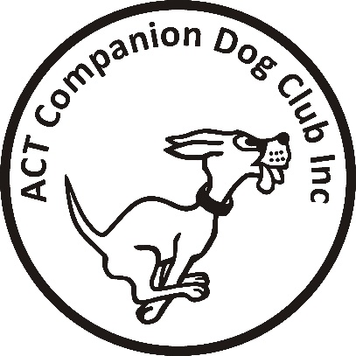
Online Entries close: Sunday 30 May 2021

ACT COMPANION DOG CLUB
DOUBLE OBEDIENCE TRIAL
Saturday 5 June 2021
Venue: ACT CDC grounds, 240 Narrabundah Lane, Symonston ACT 2609
AM TRIAL PM TRIAL
Judges UDX … Ms Judy Van Der Vegt (NSW) UDX … Mr Kyle Charnock (NSW)
UD, CD … Mr Kyle Charnock (NSW) UD … Ms Maryanne Fazekas (NSW)
CDX, CCD … Ms Maryanne Fazekas (NSW) CDX, CCD … Ms Judy Van Der Vegt (NSW)
CD … Ms Cheryl Neal (ACT)
Starts 9.30 am Not before 12.30pm
Check-in 8.45 – 9.15 am 11.45am – 12.15 pm
Entry fee $11.00 $11.00
Entries to Show Manager
Catalogues posted on ACT region obedience & rallyo trialling group Facebook page
or, if requested, to email address on your entry.
All enquiries Judith Barlow - 0403 199 847 no calls after 9pm please, judespitz@netspeed.com.au
Awards Sash for 1st, 2nd and 3rd place for qualifying scores.
Sash for all qualifying scores and titles gained on the day.
Dogs ACT Rep: Ms Cath Perry
Conditions of entry
By entering this event you agree to follow ACT Government, Dogs ACT and ACT Companion Dog Club COVID-19 guidelines
- ACT Government COVID-19 restrictions: https://www.covid19.act.gov.au/what-you-can-do
- Should it be necessary to restrict the number of entries due to COVID-19 requirements or cancel any entries or the trial due to an outbreak of COVID-19, entrants will be advised and refunded.
- If you have any symptoms of COVID-19 or have been in contact with anyone suspected of having COVID-19, please stay at home.
- The Club shop will not be open. BYO meals and refreshments.
- The clubhouse will be closed and the only people permitted entry will be trial officials.
- No off-leash exercising of dogs on grounds except in designated fenced areas, away from the trial rings.
- The club reserves the right to make any changes to ensure the smooth running of the trial, including substituting or appointing additional judges, and accepting or rejecting entries.

