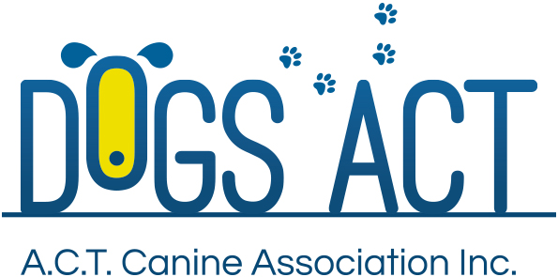
ACT Canine Association Inc. (ABN 11150955611) trading as Dogs A.C.T.

DUPLICATE CERTIFICATE OF REGISTRATION APPLICATION
Only one certificate of registration should exist for each ANKC registered dog ay any given time.
That dog must be resident in Australia and owned by a financial member of a State Canine Control.

REGISTERED OWNER :
ADDRESS:
 |  |  |  |  | POST CODE:
PHONE NUMBER: |  |  | MOBILE:
MEMBERSHIP NUMBER:
NAME OF DOG:
REGISTRATION No: |  |  |  |  |  | SEX:
REASON FOR DUPLICATE CERTIFICATE:
I CERTIFY THAT I AM THE OWNER OF THE ABOVE DOG AND I AM APPLYING FOR A DUPLICATE CERTIFICATE OF REGSITRATION:
Signature. |  |  | Date.
Signature. |  |  | Date.
The list of Fees for these services is on the Dogs ACT website / Forms & Fees. Payment required
Mail applications to – PO Box 815, DICKSON ACT 2602
Or
Return the application to the Dogs ACT Office at the Dog Grounds, Exhibition Park in Canberra (EPIC), Flemington Road, Mitchell
Your application for a Duplicate Certificate of Registration will be determined by Dogs ACT Council. The Council meets on the second Wednesday of each month.

