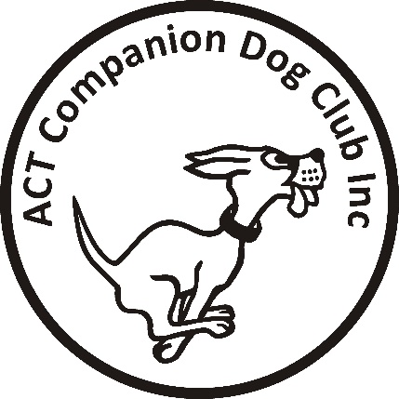

ACT COMPANION DOG CLUB Inc.
Tracking Trial
Sunday 15th August 2021
Venue: Braidwood area

Judge 1: Dr Sandra Hassett (ACT)
Judge 2: Mr Jake Blight (NSW)
Check In and Vetting: 8am
Trial Commences: 8.30am

Entry fee: $25 per entry

Entries close: C.O.B. Thursday 5th August 2021.
The Tracking Trial Manager
PO Box 4048 KINGSTON ACT 2604
0427 433 961
Email: contact@actcdc.org.au
PAYMENT MUST ACCOMPANY ENTRIES BY CLOSING DATE

Please include an email address with entry for map and further details of trial.

IF AN EXCESSIVE ENTRY IS RECEIVED, A BALLOT WILL BE HELD AND COMPETITORS WILL BE CONTACTED TO ADVISE THE OUTCOME.

The ACT Companion Dog Club reserves the right to make any changes that will ensure the smooth running of the trial, including substituting or appointing additional judges, and to accept or reject entries.

In the event that there are suitable tracks available and sufficient time and helpers, competitors may be offered the opportunity to ‘track on’

CONDITIONS OF ENTRY

COVID-19: This trial shall be conducted in accordance with the recommendations of Dogs ACT and ACT Health. Any special or additional requirements will be made available on the Club’s Facebook Page and emailed to all entrants. All officials, competitors and attendees shall agree to abide by the recommendations relating to conduct of the trials and agree to follow the directions of Club Officials in relation to enforcing the requirements.

In accordance with current advice from ACT Health and Dogs ACT, ACT CDC wishes to advise that this trial will be restricted to competitors that meet the following criteria:
- Handlers, officials, and visitors must NOT have been in a COVID Hot Spot as identify by ACT Health and/or NSW Health in the 14 days prior to the date of the trial
- ACT Health Travel Advice - https://www.covid19.act.gov.au/community/travel
- ACT Health Covid Hot Spots - https://www.covid19.act.gov.au/community/travel/nsw
- NSW Government on NSW travel: https://www.nsw.gov.au/covid-19/rules/border-restrictions

Should it become necessary to restrict the number of entries due to Covid-19 requirements, postpone or cancel the trial due to an outbreak of Covid-19, entrants will be advised and refunds provided.

- If you have even mild symptoms please stay at home and get tested.
- Total numbers of persons on the grounds shall not exceed the ACT Government Guidelines - https://www.covid19.act.gov.au/what-you-can-do, at the time of the trial.
- There shall be no paper catalogues issued at this event.
- Catalogue will be available via email, and the Facebook Group “Canberra Tracking”.

