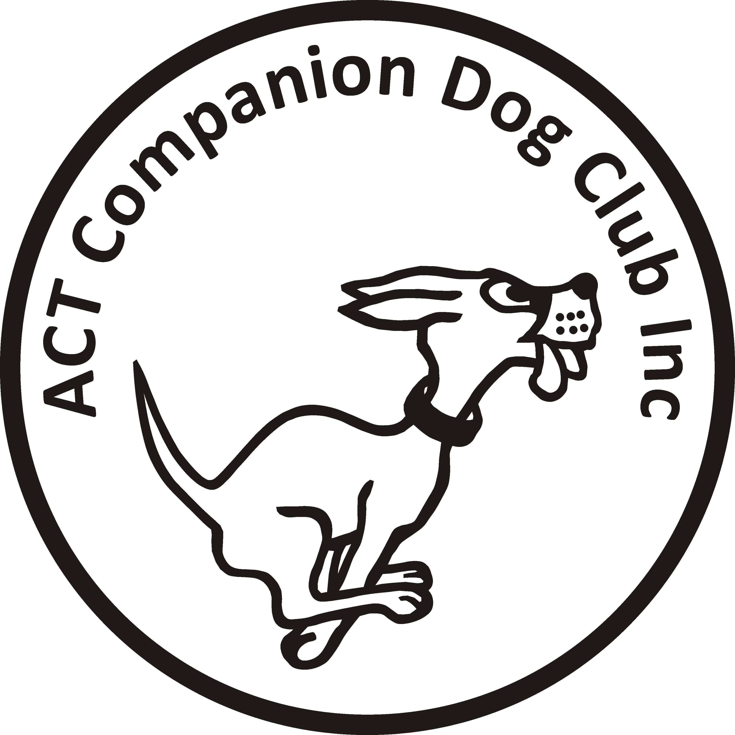
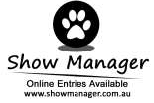
ACT COMPANION DOG CLUB
Rally Trial
Saturday 15 January 2022 **Online Entries Only**

Entries Close: 7 January 2022
Venue: ACT CDC grounds Narrabundah Lane Symonston

Ring 1 Ms Sue Turner
Novice, Advanced,Excellent, Masters (Trial 1)

Ring 2 Ms Judy Van Der Vegt
Masters, Excellent, Advanced, Novice (Trial 2)

Both trials commence 6pm. Check in 5.15pm-5.45pm
Entry by Show Manager only. No paper entries
Entry fee: $11 or $20 per dog for RAE (combined entry for Adv/Exc same dog)
Catalogues: Will be available on the ACT Region Obedience and Rally Trialling Group Facebook page and a running sheet will be available at each ring.
Catering: There will be no food or drink available at the trial for competitors.
Trial Manager: Laraine Frawley 0418 246 700. No calls after 9pm
Awards: Sash for 1st, 2nd and 3rd place getters (Qualifying scores only). Sash for titles gained on the day.

The Club reserves the right to amend the judges and judging order should the entries require
The club reserves the right to accept or decline entries
ACT CDC thanks all participants for their understanding and patience as we run the trial in a COVID safe way.

CONDITIONS OF ENTRY

- By entering this event you agree to follow current ACT Government, Dogs ACT and ACT Companion Dog Club COVID-19 guidelines
- Should it be necessary to restrict the number of entries due to COVID-19 requirements or cancel the trial due to an outbreak of COVID-19, entrants will be advised, and refunds provided.
- If you have any symptoms of COVID-19 or have been in contact with anyone suspected of having COVID-19, stay at home.

