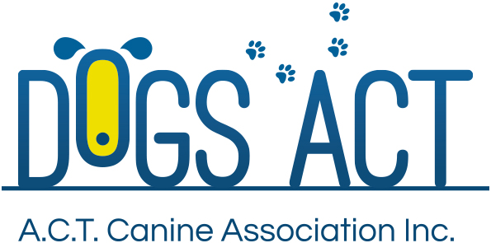 |  | APPLICATION FOR ACCEPTANCE TO THE 2022 SCENT WORK  JUDGES TRAINING SCHEME  CLASS: NOVICE/ADVANCED

Applicant Information
Surname: |  | First Name:
Current Address:
City: | State: |  | Postcode:
Phone: |  | Mobile:
Email:
Dogs ACT Membership No: |  | Date Joined:

applicant declaration
I declare that:
- I am a member of an ANKC Member Body for a period of not less than three (3) years prior to the application and be a current financial member of Dogs ACT
- I am over eighteen (18) years of age by the closing date for applications.
- I am resident in the ACT.
- I have personally trained and trialled a dog to a minimum of a Scent Work Novice (SWN) title.
- I have at least three (3) years’ experience in scent work training/education/instructing.
- I have stewarded in Novice/Advanced elements at a minimum of three (3) Scent Work trials.

APPLICANT’S SIGNATURE
Signed: |  | Date:

APPLICATION FEE: $65.00

this FEE must BE PAID AT THE TIME OF SUBMISSION OF THE APPLICATION
Preferred method of payment is by direct debit BSB:(112908) Account: 050051244 (Ref: SWsurname – please forward payment receipt with application) or Do we include option to pay be credit card (as per annual renewal form) or ask for phone payment during office hours?

