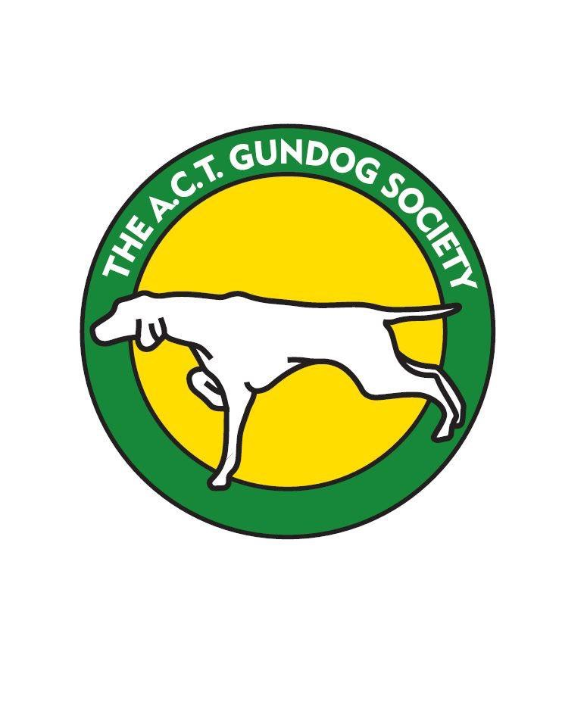
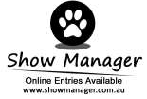
ACT GUNDOG SOCIETY
Scentwork Trial
7th and 8th May 2022
**Online Entries Only**

This trial is open to All Breeds and Associates

Entries Close: Friday 15 April or when maximum numbers are reached.
Venue: ACT Greyhound Club corner of Jerrabomberra Avenue and Narrabundah Lane Symonston ACT.
The venue is also known as Symonston Park.
Judges: Saturday Ms Jo Bates (Vic) Interiors Excellent followed by Advanced
Ms Peta Clarke (NSW) Vehicles Excellent followed by Advanced
Mr John Sam (ACT) Exteriors Excellent followed by Advanced

Sunday: Ms Jo Bates (Vic) Exteriors Excellent followed by Advanced
Ms Peta Clarke (NSW) Containers Excellent followed by Advanced
Mr John Sam (ACT) Vehicles Excellent followed by Advanced

Scents to be used: Advanced (birch and clove).Excellent (birch ,clove,cypress).
Trial will commence 9am. Check in 8am to 8.30am. Competitor briefing at 8.45am
Entry by Show Manager only. No paper entries
Entry fee: $15 per element.
Catalogues: Will be available on the Canberra Canine Nosework Facebook page
Catering: There will be no food or drink available at the trial for competitors.
There is no camping on the grounds.
Trial Manager: Laraine Frawley fieldgold@grapevine.net.au 0418 246 700. No calls after 9pm
Awards: Sash for 1st, 2nd and 3rd place getters Sash for titles gained on the day.
Presentations will be at the conclusion of each days trial.

The Club reserves the right to amend the judges and judging order should the entries require
The club reserves the right to accept or decline entries

CONDITIONS OF ENTRY

- By entering this event you agree to follow ACT Government, Dogs ACT and ACT Gundog Society COVID-19 guidelines
- If it should be necessary to cancel the trial due to an outbreak of COVID-19, entrants will be advised, and refunds provided.
- Failure to adhere to any instruction issued by an official shall result in the handler being required to immediately leave the grounds.
- If you have any symptoms of COVID-19 or have been in contact with anyone suspected of having COVID-19, stay at home.

