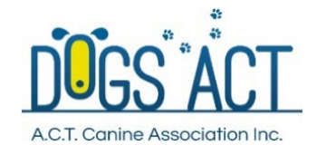
ONLINE ENTRIES CLOSE MONDAY, 9 MAY 2022
DOGS ACT ANKC SCENT WORK ELEMENT TRIAL
ADVANCED CONTAINERS (Anise and Clove)
THURSDAY, 12 MAY 2022
Dogs ACT, EPIC, Stirling Ave & Federal Hwy, Mitchell, ACT
Judge: John Sam (ACT)
Trial details:
- Online entries only - $15 per entry available at https://showmanager.com.au
- Entries capped at 35
- Running order will be provided at the event and on Canberra Canine Nosework Facebook Site
- Commences 6pm. Check-in 5:15pm to 5:45pm
- Ribbons for 1st place, 2nd place, and 3rd place and title ribbon
Additional Information
A separate entry form must be submitted for each entry (s8.1.2 of the Scent Work Rules).
It is the competitor’s responsibility to enter only the classes they are eligible to enter. Refer to s6.1 Titling Classes and s6.2 Progression through the Titling Classes of the ‘Rules’ (specifically s6.2.2 and s6.2.3) re eligibility requirements for entering a trial.
Competitors should not visit the trial location prior to the trial date. Many search locations are
real-life environments and such visits may risk losing the opportunity to use the location in the future.
Dogs ACT reserves the right to make any changes that will ensure the smooth conduct of the trial, to substitute or appoint additional judges and to accept or reject entries.
COVID-19: These trials shall be conducted in accordance with the recommendations of Dogs ACT, the ANKC and ACT Health. Any special or additional requirements will be made available on the Dogs ACT Facebook Page and emailed to all entrants. All officials, competitors and attendees shall agree to abide by the recommendations relating to conduct of the trials and agree to follow the directions of Trial Officials in relation to enforcing the requirements.

