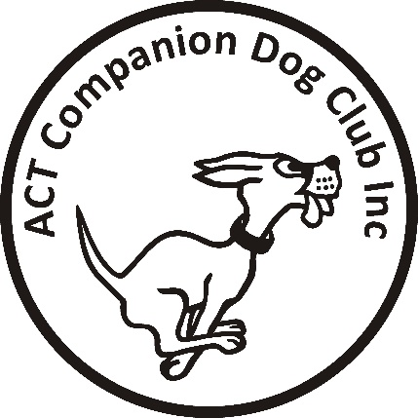

ACT COMPANION DOG CLUB Inc.
Tracking Trial
Sunday 19th June
Venue: Braidwood area

Judge 1: Dr Sandra Hassett (ACT)
Judge 2: Mr Jake Blight (NSW)
Check In and Vetting: 8am
Trial Commences: 8.30am

Entry fee: $25 per entry

Entries close: Paper: C.O.B. Thursday 9th June 2022
The Tracking Trial Manager
PO Box 4048 KINGSTON ACT 2604

Online Entries: Close Sunday 12th June

Other information: PAYMENT MUST ACCOMPANY ENTRIES BY CLOSING DATE
Please include an email address with entry for map and further details of trial.

IF AN EXCESSIVE ENTRY IS RECEIVED, A BALLOT WILL BE HELD AND COMPETITORS WILL BE CONTACTED TO ADVISE THE OUTCOME.

Contact details: Mobile (plus on the day contact): 0427 433 961
Email: contact@actcdc.org.au

The ACT Companion Dog Club reserves the right to make any changes that will ensure the smooth running of the trial, including substituting or appointing additional judges, and to accept or reject entries.

In the event that there are suitable tracks available and sufficient time and helpers, competitors may be offered the opportunity to ‘track on’

CONDITIONS OF ENTRY

COVID-19: This trial shall be conducted in accordance with the recommendations of Dogs ACT and ACT Health. Any special or additional requirements will be made available on the Club’s Facebook Page and emailed to all entrants.

This trial will be conducted in accordance with the ACT Companion Dog Club’s Work, Health & Safety COVID-19 Safety Plan in force at the time of the event, which is available to read here: https://actcdc.org.au/wp-content/uploads/2022/02/Safety-Plan-COVID-19-Stage-7-Ready-Reference-12-Feb-2022.pdf
All officials, competitors and attendees shall agree to abide by the recommendations relating to conduct of the trials and agree to follow the directions of Club Officials in relation to enforcing the requirements.

Additionally:

- If you have even mild symptoms please stay at home and get tested.
- There shall be no paper catalogues issued at this event.
- Catalogue will be available via email, and the Facebook Group “Canberra Tracking”.

