Entries Open: 11 August 2022 Entries Close: when entry limits are reached or 1 September 2022
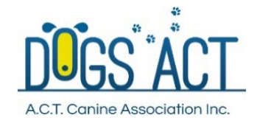
DOGS ACT SCENT WORK TRIAL
BUNGENDORE SHOWGROUND, MATHEWS LANE, BUNGENDORE
SUNDAY 18th SEPTEMBER 2022
Classes to be judged: Novice, Advanced, Excellent
Elements: Vehicles, Containers, Exterior, Interior
Make a weekend of it – enter LAKE GEORGE AND WAMBOIN CLUB SCENT WORK TRIAL on 17 September 2022
also at Bungendore Showground
Ph & Extreme Weather Ph: 0438 931 712

JUDGES
Ms Angela Hervey-Tennyson (VIC) Excellent, Advanced Vehicles
Ms Jo Bates (VIC) Excellent, Advanced Containers
Mr John Sam (ACT) Novice Vehicles, Excellent Exterior
Ms Debby Lamprecht (QLD) Novice Containers, Advanced Interior
Online entries only. Entries are limited to 80 per judge per trial.
There must be only one dog and handler per class. Any owner entering two dogs in the same class must advise the name of a second handler (who must be registered with a member body). Dogs from the same family will be run concurrently
Order of Judging: AM: Excellent and Novice; PM Advanced and Excellent
Judging Commences both days: Novice/Excellent 9.00am Advanced/Excellent: Not before 12pm
Vetting/Check In Time: Novice/ Excellent 7.45 - 8.15am Advanced/Excellent: 11:30-12:00pm
Compulsory Briefing: Novice/Excellent 8.45am Advanced/Excellent: After lunch, but not before noon.
Vetting Officer: Dogs ACT Member DOGS ACT Representative: TBA
Entry Fees: $15.00 per element per class Catalogues: Will be provided online
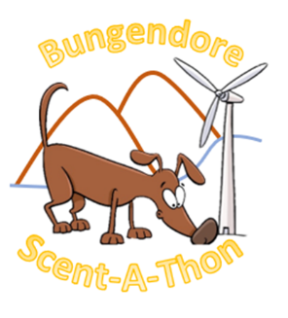
Odours used: Novice: Clove Advanced: Anise and Cypress Excellent: Clove, Cypress and Anise

PRIZES
1st, 2nd, 3rd each class/element: Ribbon/Sash/Prize. Qualifier/Titles: Ribbon/Sash
HIGH IN TRIAL: Rosette
SPECIAL ENCOURAGEMENT AWARDS (Prizes)
NOVICE: Best team work.
ADVANCED: The GETSMART Award
***COVID SAFE CONDITIONS WILL APPLY, and entries MAY BE RESTRICTED based on the NSW and ACT COVID RULES IN EFFECT at the time of this event***
All officials, competitors and attendees shall agree to abide by the recommendations relating to conduct of the trials and agree to follow the directions of Trial Officials in relation to enforcing the requirements.
Additional Information
- Dogs ACT reserves the right to make any changes that will ensure the smooth conduct of the trial, to substitute or appoint additional judges and to accept or reject entries
- A separate entry form must be submitted for each entry (Scent Work Rules: s8.1.2)
- Competitors must only enter the classes they are eligible to enter (Scent Work Rules: s6.1 and s6.2)
- Competitors should not visit the trial location prior to the trial date. Many search locations are
real-life environments and such visits may risk losing the opportunity to use the location in the future.
- Spectators will only be permitted for Excellent (space permitting). Any spectator will have to remain at the spectator location for the duration of the class, with no speaking, no food and no drinks.
UPGRADES: may be allowed only if numbers in the higher classes permit. Upgrades must be made online through Show Manager until 13 September 2022. NO upgrades via any other means will be accepted. No upgrades will be allowed as a result of qualifications obtained at the 17 Sept 2022 trial
No target odour to be brought to the grounds
Bitches in oestrum may NOT be trialled

