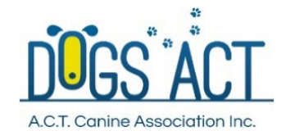
Expression of Interest
JO BATES WORKSHOPS AND INFORMATION EVENINGS
DUE BY 8 JULY 2022
to Julie Cutts: jarrah236@gmail.com

Applicant Details
Name: |  |  |  | Dogs ACT Membership No.
Address:

Contact Number:
Email:
Which workshop are you expressing an interest in? – Please circle
Novice/ Advanced  13/14 August 2022 |  |  | Advanced/ Excellent  2/3 September 2022 |  |  | Masters  4 September 2022
*Please note you may only be selected for either Novice/Advanced or Advanced/Excellent workshops;
Masters is an add on to the Advanced/Excellent workshop
If you are not sure which workshop would suit your needs best, please reach out to the contact to discuss
Are you flexible about which workshop you come to if there is a choice of only one?
Please tick below
Yes |  |  |  |  | No
Which information evening are you expressing an interest in or both? – Please circle
Information Evening  12 August 2022 |  |  | Information Evening  2 September 2022
Questions
Current dogs owned:
Breed:
Name (s):
Age(s):
Sex: (Entire/desexed)
Demonstration Dog – Please tick below
Yes |  |  |  |  | No
Level of Scent work trialling:
Trialling at which level: Please circle
Novice |  |  | Advanced |  |  | Excellent
Is your dog proficient in all odours? Please tick below
Yes |  |  |  |  | No
If not, which odours? Please tick below
Birch | Anise |  |  |  | Clove |  | Cypress
Existing Qualifications: (titles/ passes etc)

Scent Work Experience:
What is your history/background in Scent Work?

Is there a particular training methodology or Scent Work System (eg K9 Nosework/Fenzi/online courses) that you have used?

Objectives:
What would you like to achieve out of the workshop?

Issues/ Problems?
Are you having any particular problems/issues with your SW training that you would like to understand better:

Anything else you would like to mention?
Medical conditions, allergies

