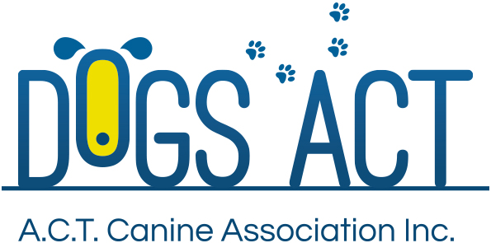
COUNCIL ELECTION – TUESDAY 30 AUGUST 2022
PROXY NOMINATION FORM
TO BE GIVEN OR EMAILED TO THE DOGS ACT OFFICE BEFORE 7PM ON MONDAY 29 AUGUST 2022

MEMBER
I, (Name)
Of (Address)
Being Financial Member of Dogs ACT # (Member Number)
Hereby Nominate the Financial Member listed below to Vote as my Proxy for all matters to be considered at the 2022 AGM of Dogs ACT.
Date: | Signature:
PROXY
I, (Name)
Of (Address)
Being Financial Member of Dogs ACT # (Member Number)
Hereby agree to be the Proxy Member for the Financial Member listed above and to Vote as agreed for all matters to be considered at the 2022 AGM of Dogs ACT.
I am aware that I may hold a Maximum of Five (5) Proxy Votes.
Date: | Signature:
Date received:
Initials of Recording Officer:

