Entries close: 15 November 2022 at 9.30am (online)

BELCONNEN ALL BREEDS KENNEL CLUB INC
(Affiliated with DogsACT)
Exhibition Park in Canberra, Federal Highway, Canberra

Three All Breeds Championship Shows over two days
19th & 20th November 2022
Classes to be judged: 1, 2, 3, 4, 5, 10, 11 & 18 (dogs & bitches)

 | Saturday – AM show | Saturday – PM show | Sunday
Toys | Mr T Horchner (Vic) | Mrs E Wells (NSW) | Ms C Loft (NSW)
Terriers | Mrs E Wells (NSW) | Ms D Howell (NSW) | Mr T Horchner (Vic)
Gundogs | Ms N Harrison (NZ) | Mr T Horchner (Vic) | Ms D Howell (NSW)
Hounds | Ms D Howell (NSW) | Ms M Clegg (Vic) | Mr G Markotany (NSW)
Working Dogs | Mr G Gregory (NSW) | Ms C Loft (NSW) | Ms M Clegg (Vic)
Utility | Ms C Loft (NSW) | Ms C Paine (NSW) | Ms N Harrison (NZ)
Non-Sporting | Ms M Clegg (Vic) | Ms N Harrison (NZ) | Mrs E Wells (NSW)
3-6 month S/S |  |  | Ms M Clegg (Vic)
6-12 Month S/S |  |  | Mr T Horchner (Vic)
GENERAL SPECIALS | Ms M Clegg (Vic) | Ms E Hindley (ACT) | Mr T Horchner (Vic)
ACTCA Rep: Mrs Trish Dyer
Entry Fees: Class entries: $15.00 per entry (includes $2.50 DogsACT Levy)
Sweepstakes (SUNDAY ONLY): $10.00 per entry
Catalogues: Online catalogues only – will be available Thursday 17th November
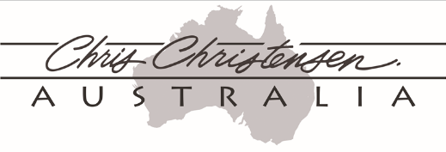
Judging commences: Saturday – AM show – 8:30am
Saturday – PM show – Not before 12 noon
Sunday – 8.30am with sweepstakes
Junior Handlers during luncheon break on Saturday only
Entries close with: 15th November 2022 9.30 AM– No refunds after 1st November 2022
Email enquires: silvafyr@bigpond.net.au
Phone 0400 375 090 (call between 6pm and 9pm only)
NUMBER CARDS TO BE EMAILED TO EXHIBITORS

Camping: Must be pre-booked with DogsACT
Telephone: 02 6241 4404 or email: admin@dogsact.org.au

The Club reserves the right to appoint substitute judges if necessary
Show Committee members do not handle at these shows

