ONLINE ENTRIES CLOSE 14 OCTOBER 2022

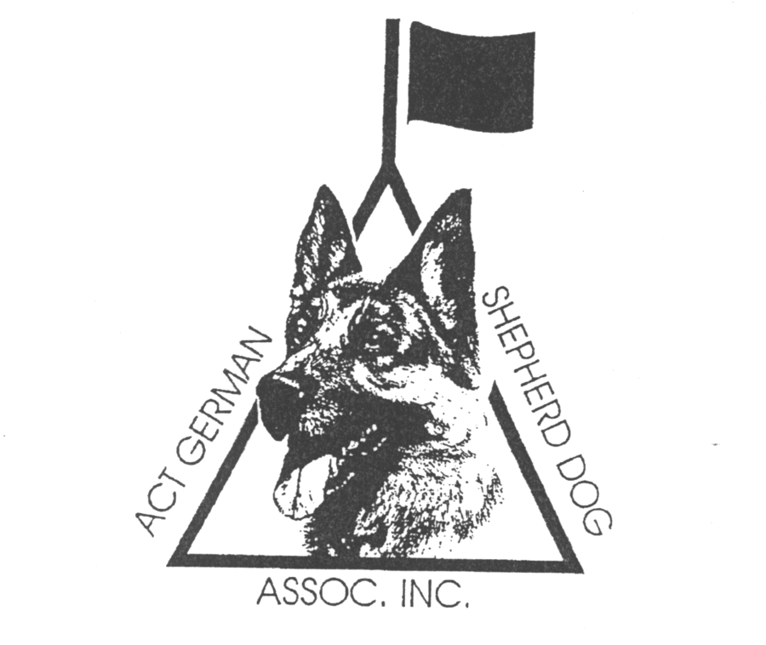ACT GERMAN SHEPHERD DOG ASSOCIATION INC
ACT GSD CLUB ANKC SCENT WORK ELEMENT TRIAL
SUNDAY 23 OCTBOER 2022
EXCELLENT INTERIOR (Birch, Clove, Cypress)
EXCELLENT VEHICLES (Birch, Clove, Cypress)
ACT GSD Club, EPIC, Flemington Road, Mitchell, ACT
Judge: Natasha Neppl

Trial details:
- Online entries only - $15 per entry available at https://showmanager.com.au
- Entries capped at 70 total across both elements
- Running order will be provided at the event and on Canberra Canine Nosework Facebook Site
- Gate and parking details will be provided with the running order
- Commences 9:30am. Check-in 8:30am to 9:00am. Competitors’ briefing 9.15am
- Ribbons for 1st place, 2nd place, and 3rd place and title ribbon
- Trial Manager: Victoria Swalling – 0401362265 ( text message preferred) – no calls after 9.30pm
NOTE: Dogs ACT is also running a trial on Sunday, 23 October 2022 (Excellent Containers, Advanced Interior, Advanced Exterior). The trials are being run collaboratively. Excellent will be run first. Trialers entering both trials will move from one search area to the next. The venues are approximately 250m apart (see attached map).
Additional Information
A separate entry form must be submitted for each entry (s8.1.2 of the Scent Work Rules).
It is the competitor’s responsibility to enter only the classes they are eligible to enter. Refer to s6.1 Titling Classes and s6.2 Progression through the Titling Classes of the ‘Rules’ (specifically s6.2.2 and s6.2.3) re eligibility requirements for entering a trial. No upgrades will be allowed after the trial closing date.
Competitors should not visit the trial location prior to the trial date. Many search locations are
real-life environments and such visits may risk losing the opportunity to use the location in the future.
ACT German Shepherd Dog Association Inc reserves the right to make any changes that will ensure the smooth conduct of the trial, to substitute or appoint additional judges and to accept or reject entries.
COVID-19: These trials shall be conducted in accordance with the recommendations of Dogs ACT, the ANKC and ACT Health. Any special or additional requirements will be made available on the Dogs ACT Facebook Page and emailed to all entrants. All officials, competitors and attendees shall agree to abide by the recommendations relating to conduct of the trials and agree to follow the directions of Trial Officials in relation to enforcing the requirements.

