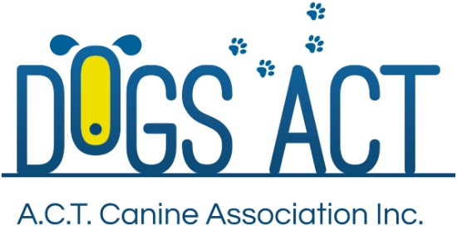
ACT Canine Association Inc. (ABN 11150955611) trading as Dogs A.C.T.
Exhibition Park, Federal Highway, Mitchell, ACT.
PO Box 815, Dickson ACT 2602. Phone 02 62414404.
Email: administrator@dogsact.org.au or visit: http://www.dogsact.org.au
Office hours 9.30am to 2.30pm Tuesday to Thursday

Dogs ACT Show Representatives Report

AFFILIATE:
EVENT:
DATE HELD:
COMMENCED: |  | NO OF ENTRIES:

TYPE OF SHOW:
VENUE AS PER ACT REGULATIONS:
RINGS CORRECT SIZE:
COPY OF ACT REG AVAILABLE:
TEMPERATURE AT START OF SHOW:
ANY HEALTH OR WELFARE ISSUES:

IF LATE START – REASON:
IF LATE FINISH – REASON:
LIST VENDORS IN ATTENDANCE:

LIST STEWARDS APPOINTED AND PRESENT FOR THIS EVENT:

GENERAL COMMENTS:

COMPLAINTS FROM EXHIBITORS & ACTIONS TAKEN: | Include witness details or list attached documents.

NAME: SIGNATURE:

INSTRUCTIONS FOR DOGS ACT REPRESENTATIVES

The Dogs ACT Representative must be on the official Dogs ACT Representative list and cannot be the President, Secretary, Event Manager or Treasurer of the Affiliate running the event.

The Dogs ACT Representative is appointed to observe the conduct of the event and shall act only in that capacity and cannot personally carry out any other function on that day.

The Dogs ACT Representative must obtain a copy of the ACTCA Rules and Regulations from the Dogs ACT Administrator prior to the event concerned if he or she is not already in possession of the Rules, and must become familiar with them.

The Dogs ACT Representative must obtain a copy of the ACT Representative’s Report form prior to or on the day of the event and complete it immediately after the conclusion of the event.

If an exhibitor or other person (excluding members of the general public visiting the event) wishes to lodge a complaint, this complaint must be submitted to Dogs ACT in writing on the day together with $100.00 in accordance with Regulation Part 18 Section 3 unless it is an Aggressive Dog Complaint.

On completion of the event, the Dogs ACT Representative must obtain the Judges Cards or Trial sheets and a marked copy of the Trial Catalogue. These items must be lodged with the Dogs ACT Administrator at the Dogs ACT Office, EPIC, Federal Highway, Canberra or PO Box 815, Dickson ACT 2602 within two (2) working days of the event, together with the ACT Representatives Report and any written complaints.

