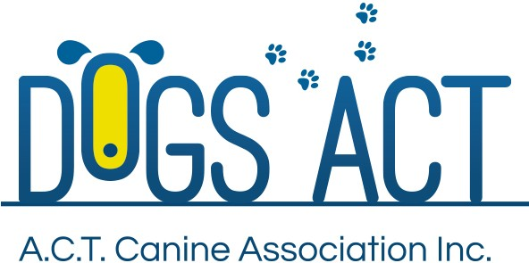
APPLICATION
2025 OBEDIENCE JUDGES TRAINING COURSE
CLOSING DATE 19 DECEMBER 2024

COURSE - CLASS
I apply to undertake the Obedience Judges Training Course in the following class/es:
CCD - Novice - Open – UD – UDX (circle appropriate Class/es)

APPLICANT INFORMATION
Name: |  | First Name:
Address:
City: | State:- |  | Postcode:
Phone: |  | Mobile:
Email:
Dogs ACT Membership No: |  | Date Joined:
APPLICANT DECLARATION
I declare that:
(i) I have been a member of an ANKC Member Body for at least three (3) years. (Give details if other than the Dogs ACT).
(ii) I am over eighteen (18) years of age.
(iii) I am resident in the ACT.
(iv) I hold an ANKC (Obedience) CCD/ Novice/ Open/ UD Judges Licence. Circle appropriate licence.

Date issued:
State/Territory where issued:

(v) I have personally trained and trialled a dog to its CCD/ Novice/ Open/ UD/ UDX title. Circle highest title obtained.

Date title granted:

Name of dog:

----------------------
Where an applicant for the UD or UDX course has not personally trained and trialled a dog to its UD title - I have personally
trained and trialled a dog in the UD ring on at least three occasions.

Dates of last three UD trials:

Name of affiliate/s:

Name of dog:

Where an applicant for the UD course has neither personally trained and trialled a dog to its UD title nor personally
trained and trialled a dog in the UD ring on at least three occasions – I have judged at least five Open Obedience trials and, in the two
years preceding this application, I have stewarded in the Utility Dog ring on at least five occasions at different trials.

Dates of last five UD trials judged:

Name of affiliate/s:

-----------------------------------------------
Dates of UD trials stewarded:

Name of affiliates:

Number of dogs competed in each ring:

- In the two (2) years preceding this application:

  - I have instructed in Obedience classes at a Dogs ACT or other ANKC Member Body affiliated Club:
Name of Club:
Dates of classes:
Levels of classes:

  - I have stewarded at Obedience trials:
Name of Club/s:
Dates of trials:
Classes stewarded:

  - I have been involved in other related club or training activities: Name of Club:
Discipline (e.g., Obedience, Rally, Tricks, DWD, Agility, Other):
Role/function undertaken (e.g., Rally instructor, Trial Manager):

Note: The purpose of providing the information required in this section is to demonstrate your interest and commitment to Obedience or other related activities. You may not have had experience in each of the areas – just provide the requested information for the areas in which you do – leave the other areas blank.
- I have personally trained and trialled a dog to a title in an ANKC sporting discipline/s other than Obedience. Provide details below of highest titles obtained in each discipline.

Discipline:
Title:
Date title granted:
Name of dog:

Note: The purpose of providing details of titles in other dog sports disciplines is to demonstrate your experience and ability in dog training. If you have not obtained such titles, leave the area blank.
(viii) I am physically fit and capable of judging in accordance with the Rules and Regulations and if required I am prepared to undergo a medical fitness test and/or vision test at the discretion of Dogs ACT. I further accept that Dogs ACT may at its absolute discretion refuse to grant any renewal of licence and may cancel or suspend for any period or vary in any way
any licence already granted or to be granted.

APPLICANT’S SIGNATURE
Signed: |  | Date:
APPLICATION FEE: $65.00
PAYABLE AT THE TIME OF SUBMISSION OF APPLICATION

